**MUKONO JUNIOR SCHOOL-NGANDU**

****

**P.7**

**SCIENCE**

**REVISED TEACHING NOTES**

**TERM 1**

**© 2023**

**P.7 SCIENCE TEACHING NOTES FOR TERM I 2023**

**LESSON 1**

**Topic: Muscular – skeletal system**

**Content: Muscular Skeletal System** (Real object” Skeleton modes)

The muscular skeletal system is a system that gives animals the ability to move. It is a composition of bones and muscles

**Skeleton**

A skeleton is a structure that gives protection and support to the body of an organism.

**Importance of a skeleton to an organism**

1. It protects delicate body organs

2. It provides support to the body.

3. It supports body movement.

4. It gives the body shape.

**Types of skeletons**

There are three types of skeleton namely:

* Exoskeleton
* Endoskeleton
* Hydrostatic skeleton

1. **Exoskeleton**.

This is the type of skeleton found outside on the body of an organism.

**Examples of organisms with exoskeleton**:

1. Insects b)Arachnids c) Myriapods d)Crustaceans

**Note:**

All arthropods have exoskeletons

These animals undergo **ecdysis / moulting** to allow growth**.**

**Moulting/ecdysis**

Moulting is the shedding of the outer cuticle in some organisms to allow growth or increase in size

1. **Hydrostatic skeleton**

This is where an organism is filled with a fluid under pressure and action of the surrounding muscles.

**Examples of organisms with hydrostatic skeleton**

* snails -earth worms -slugs
* oyster -star fish -jelly fish
* sea urchins

1. **Endoskeleton**

This is the type of skeleton found inside the body of an organism.

Endoskeletons are made of bones and cartilage

**Examples of organisms with endo skeleton**

People

Cows

Goats

Tortoise

Turtle

Snake

Tilapia

**Note;**  All vertebrates have endoskeletons

**Exercise**

1. What name is given to a frame work of bones in humans?
2. How is ecdysis important to insects?
3. What type of skeleton do the following have:
4. a slug b) atortoise
5. How can you care for your bones?
6. State the importance of calcium to the human skeleton.
7. Name any two organisms that undergo moulting.

**LESSON 2**

**The human skeleton (**Real object: Skeleton model)

This is the framework of bones in the human body.

An adult human being has about 206 bones.

The skull consists of 22 bones

The backbone consists of 33 bones

Babies have more bones than adults but some of their bones keep on joining as they grow.

**Structure of human skeleton**

**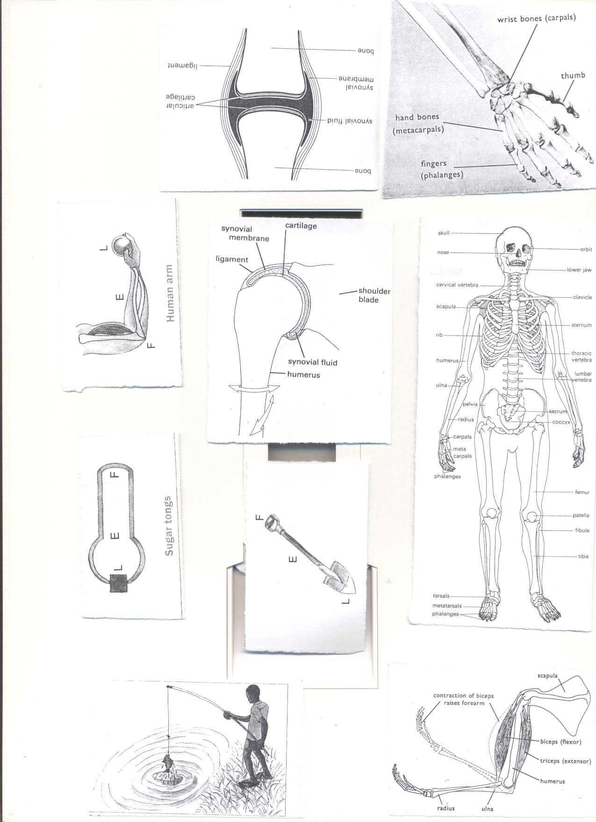**

**Exercise**

1. Name the part of the skeleton which protects the brain
2. State two importance of the ribs or rib cage.
3. In which part of the human body is the femur found?
4. Identify the two bones found in the lower arm.
5. In which body part are carpals and tarsals found
6. Carpals
7. Tarsals

**LESSON 3**

**Content: Regions of the human skeleton**

The human skeleton is made up of two regions namely:

1. Axial Skeleton
2. Appendicular skeleton

**Appendicular Skeleton**

This is the part of the skeleton which consists of bones of limbs, limb girdles and clavicle.

**Axial Skeleton**

This is the part of the skeleton which consists of the skull, ossicles, ribcage, sternum, backbones.

**Main parts of the human skeleton**

The human skeleton is made up of four main parts which include:

* The back bone (spinal column / central stem)
* The skull
* The limbs (legs and arms)
* The limb girdles (pelvis and shoulder blade)

**Exercise**

1. How is an endoskeleton different from an exoskeleton?
2. Name the bones found in the following parts
3. thigh
4. upper arm
5. Which body organs are protected by the following?
   1. skull
   2. ribcage

**LESSON 4**

**Content: Bones** (Real object: Skeleton model)

Bones are the hard tissues found inside the bodies of most vertebrates.

They are made up of mineral salts which include:

1. Calcium
2. Phosphorus

Note

1. The smallest bone in the body is the stirrup/stapes
2. The longest and strongest bone in the human body is the femur / thigh bone.

**Classifications of bones**

Bones are grouped according to their shapes and this gives us four types of bones.

**Types of bones in the human body**

There are four types of bones which include:

1. long bones
2. short bones
3. flat bones
4. irregular shaped bones

**Long bones**

These are mainly found in the arms and legs

Some long bones are found in the fingers, toes and shoulders

**Examples of long bones**

1. femur
2. tibia
3. fibula
4. humerus
5. radius
6. ulna
7. clavicle
8. metacarpals
9. metatarsals

The long bones contain yellowbone marrow which produces **white blood cells.**

**Short bones**

These are found in the feet, hands and knees

**Examples of short bones**

1. tarsals
2. carpals
3. Patella

**Flat bones**

These are found in the head, chest and hips

**Examples of flat bones**

1. pelvis
2. sternum
3. parietal bone
4. occipital bone
5. ribs
6. [scapula](http://en.wikipedia.org/wiki/Scapula)
7. Frontal bone

**Flat bones** contain red bone marrow which manufactures the red blood cells and platelets.

**Irregular shaped bones**

Most of these are found in the backbone and some in the head

**Examples of irregular shaped bones**

1. vertebra b)sacrum c)maxilla

d) mandibles e)temporal bones f)Atlas and axis bones

**Note:-**

1. The class of food that helps in the formation of strong bones is mineral salts.
2. The mineral salts that help in the formation of strong bones are calcium and phosphorus.

**Exercise**

1. Why do babies have more bones than adults?
2. List any two body parts where short bones are found.
3. Give the reason why we should include calcium in our diet.
4. State any two examples of each of the bones below:
5. Long bones b) irregular bones

**LESSON 5**

**Content: Joints** (Real object: skeleton model)

A joint is a part of the body where two or more bones meet.

**Classes of joints (main types of joints)**

Joints are divided into two main types or classes namely:

1. Movable joints
2. Immovable joints

**Immovable joints**

These are joints which do not allow movement in the body.

**Examples of immovable joints**

* Suture joints

Suture joints are the joints found in the skull

**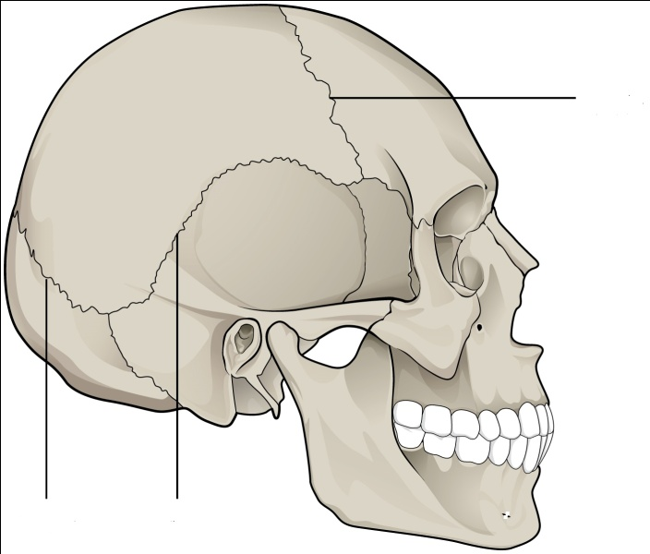A diagram showing a suture joint**

**Parietal bone**

**Frontal bone**

**Upper jaw**

**Occipital bone**

**Suture joints**

**Temporal bone**

**Lower jaw**

**Movable joints**

These are joints which allow movement in the body.

**Types of movable joints**

1. Ball and socket joints 2.Hinge joints 3.Gliding joints 4.Pivot joints

**Exercise**

1. In one sentence, give the meaning of a joint.
2. In which body part are suture joints found?
3. Why are suture joints regarded as immovable joints?
4. Identify any two bones that meet to form suture joints.
5. What are movable joints?
6. State any two examples of movable joints

**LESSON 6**

**Content: Hinge Joints**

These are the joints which allow movement in only one plane e.g.

**Examples of hinge joints**

Joint in the knee

Joint in the elbow

**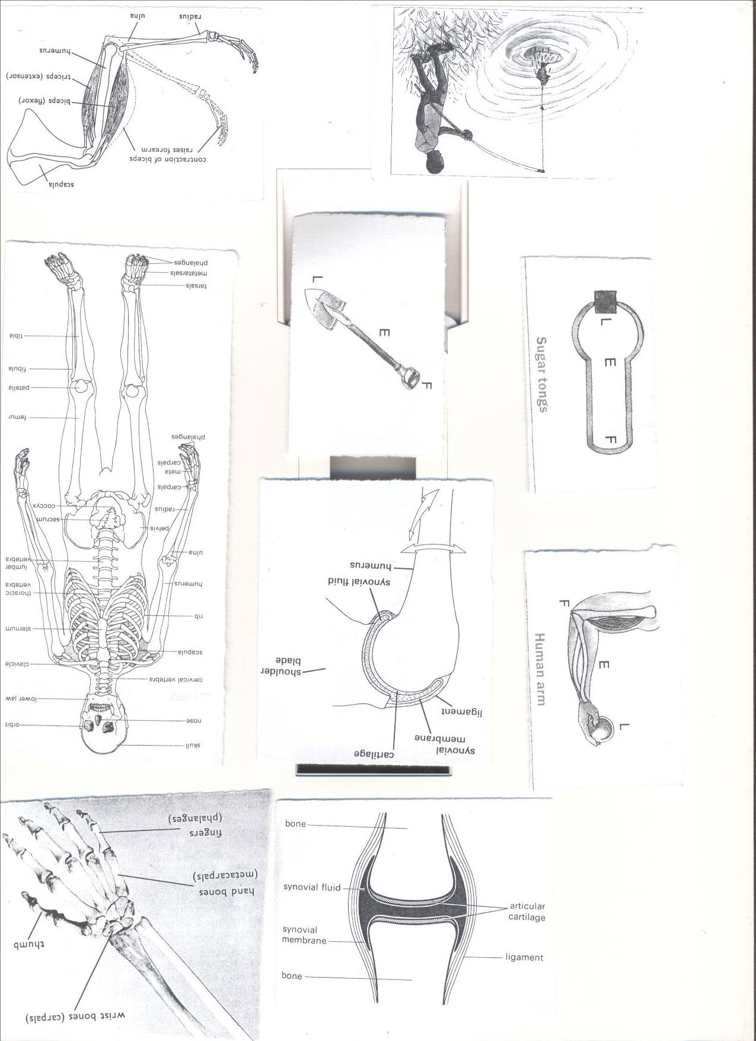A diagram showing the joint in the knee**

Joints comprise of**: tendons, ligaments, cartilage and Synovial fluid**

**A Tendon** is a tissue that joins muscles to bones.  
**A Ligament** is a tissue that joins a bone to a bone in a joint.

**Cartilage reduces friction in the joints by preventing bones from** rubbing directly onto each other.  
Inside a joint is **a lining of synovial membrane** which secretes **synovial fluid.**  
**Synovial fluid** reduces **friction** in a joint and allows free movement of bones.

This is done by making the bones in the joint slippery.

**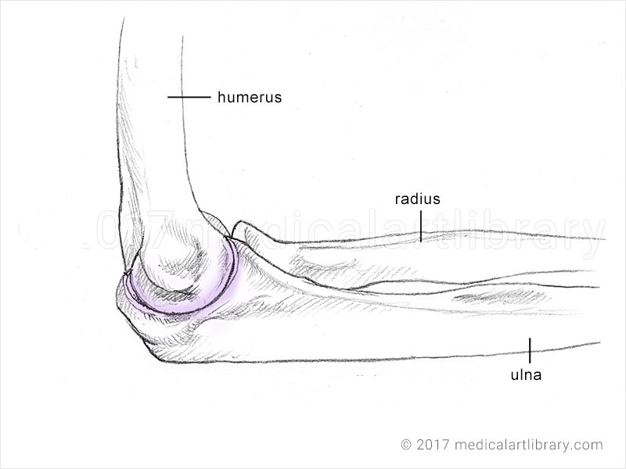Joint in the elbow**

**elbow**

**A diagram showing the ball and socket joints**

These are joints which allow movement in three planes

**Examples of ball and socket joints**

Joint in the shoulder,

Joint in the hip

**Joint in the shoulder**

**Shoulder**

**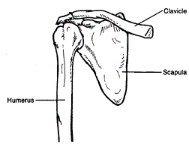**

**Clavicle**

**Scapula**

**Humerus**

**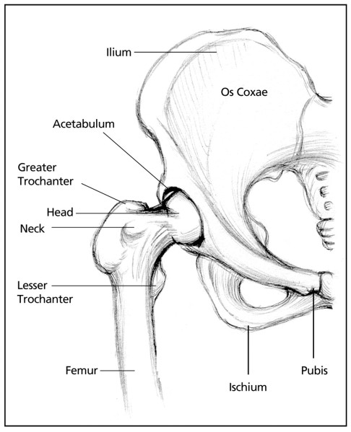A diagram showing the joint in the hip**

**Pelvis**

**Hip joint**

**Femur**

**Gliding joint-** They allow flat bones to slide over one another.eg wrist/ ankle

**A diagram showing gliding joints**



**Pivot joint**

This is a type of joint that allows rotation of certain bones in the body on another fixed bone e.g. the neck

**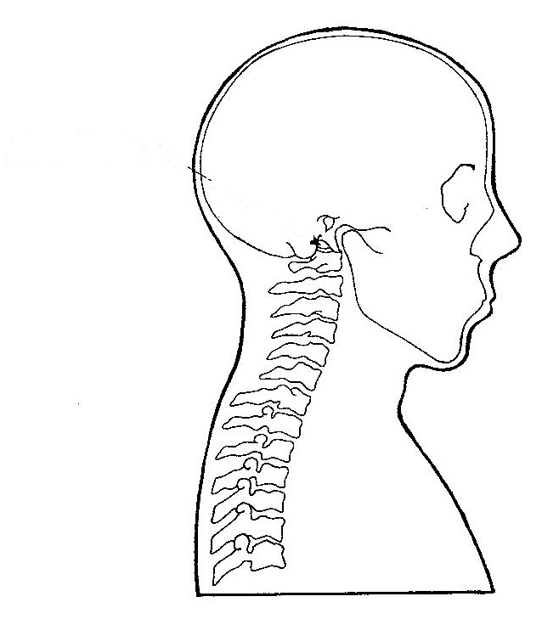Joint in the neck**

**Atlas**

**Axis**

**How is a joint adapted to a friction free movement?**  
-It contains synovial fluid which reduces friction at the joint.  
-The bones are covered with cartilage at the ends which reduce friction.

**Exercise**

1. Identify the parts of the body where hinge joints are found.
2. How are joints important to a 4 years old boy?
3. What name is given to a part where two bones meet in the human body?
4. Write down any one example of a hinge joint.
5. Why is a shoulder joint said to be a movable joint?
6. How is the cartilage similar to the synovial fluid?

**LESSON 7**

**Content: Muscles** (teacher should guide children identify the different muscles on their bodies)

A muscle is an elastic bundle of flesh under the skin that is attached to bones.

A muscle is a special elastic tissue that contracts and relaxes to produce movement.

**Types of muscles**

There are three types of muscles;

**These are;**i) skeletal muscles

ii) Smooth muscles

iii) Cardiac muscles

**Skeletal muscles**

These are muscles which are attached to the skeleton. They allow movement in the body

**Examples of skeletal muscles**

1. Biceps muscle
2. Triceps muscle
3. Calf muscle

**Smooth muscles**

These are muscles that make up different internal body organs.

**Examples**

1. Muscles of the intestines
2. Sphincter muscles
3. Ciliary muscles of the eyes

**Cardiac muscles**

These are muscles of the heart.

**Note:**

They are thick and strong tissues that pump blood out of the heart.

**Note: -**

Muscles are classified into two major groups according to their movement i.e.

1. Voluntary muscles ii) Involuntary muscles

**Voluntary muscles**

These are muscles whose movements can be controlled by one’s will.

**Examples**

* Biceps muscles
* Triceps muscles

**Involuntary muscles**

These are muscles whose movement cannot be controlled by one’s will.

**Examples**

1. Muscles of the intestines
2. Ciliary muscles of the eye
3. Cardiac muscles
4. Sphincter muscles

**Importance of muscles**

* They allow body in movement
* They are used in the storage of oxygen by the help of myoglobin
* Heart muscles pump blood in the body.
* They aid in breathing (intercostal muscles).
* Muscles of the alimentary canal aid peristalsis

**Antagonistic muscles**

These are muscles that work in pairs but have an opposite effect to each other.

**Examples of antagonistic muscles include;**

1. Biceps (flexor)
2. Triceps (extensor)

**A diagram showing Antagonistic muscles**

**Exercise**

1. What is a muscle?
2. State any two types of muscles in our bodies.
3. Why are the triceps and biceps muscles referred to as antagonistic muscles?
4. How are muscles useful in our bodies?
5. Cite any one disorder to the body muscles.
6. How can you care for your muscles?

**LESSON 8**

**Functions of the skeletal& muscular system**

1.The skeleton protects the delicate body organs

* The [**skull**](http://en.wikipedia.org/wiki/Human_skull)[**brain**](http://en.wikipedia.org/wiki/Human_brain)**,** the [**eyes**](http://en.wikipedia.org/wiki/Human_eye)[**middle**](http://en.wikipedia.org/wiki/Middle_ear)**.**
* The **vertebrae** (backbone) protect the **spinal cord**.
* The **rib cage** and [**sternum**](http://en.wikipedia.org/wiki/Human_sternum)[**lungs**](http://en.wikipedia.org/wiki/Human_lung)[**heart**](http://en.wikipedia.org/wiki/Human_heart).

2. It provides supports to the body.

3. It supports body movement.

4. It gives the body shape.

5. It manufactures red blood cells, white blood cells and platelets

6. It provides room for attachment of muscles.

**Protective functions of the skeleton**

* The skull protects the brain, eyes and inner ear.
* The ribcage protects the lungs and the heart.
* The pelvis protects the female reproductive system.
* The backbones / spine protect the spinal cord

**Diseases and disorders of bones, muscles and the system**

The muscular skeletal system can be attacked by several diseases if not well cared for. The diseases are categorized into two i.e. Diseases of the bones and diseases of the muscles.

**a)Disease of the skeleton**

* Polio
* Tuberculosis
* Cancer of the bones
* Rickets
* Arthritis

**b)Diseases of the muscles**

* Tetanus
* Leprosy

**Polio**

* It is caused by a virus
* It is also called poliomyelitis

**How it is spread**

* Through drinking contaminated water.
* Through eating contaminated food

**Effects of polio**

* Paralysis of limbs
* Weakness of the limbs
* Fever

**Control of polio**

* Immunize using polio vaccine
* Drink boiled water
* Wash hands with soap and water before eating food
* Proper use of latrines

**Tuberculosis of the bones**

* It is caused by bacteria

**How it spreads**

* Breathing in contaminated air
* Drinking unboiled milk from an infected animal.
* Contact with respiratory droplets from an infected person

**Signs of tuberculosis**

* Prolonged cough
* Loss of body weight
* Blood in sputum
* Night sweating

**Symptoms of tuberculosis**

* Pain in the chest
* Persistent fever
* Pain in the backbones, legs and arms.

**Control of tuberculosis**

* Immunize using BCG vaccine
* Early treatment of the infected people under isolation
* Drinking boiled milk

**Rickets**

* It is caused by lack of vitamin D and calcium in the body.

**Signs and symptoms of rickets**

* Weak bones
* Poor teeth development
* Bow legs / knock knee legs

**Prevention of rickets**

* Eating food rich in vitamin D and calcium
* Exposure to morning sunshine.

**Tetanus**

* It is caused by bacteria
* The bacterium enters the body through fresh cuts or wounds.
* It attacks the muscles

**Signs and symptoms of tetanus**

* Stiff muscles all over the body
* Spasm (pain) all over the body

**Control of tetanus**

* Immunize using DPT vaccine
* Early treatment of the infected person.

**Leprosy**

* It is caused by bacteria.
* It affects the skin and muscles

**Effects of leprosy**

* It can cause loss of toes, fingers, hands and feet.

**Control of leprosy**

* Early treatment

**Disorders of the skeleton**

* Fractures
* Sprain
* Dislocation

**Disorders of the muscles**

* Cuts
* Strains
* Hernia
* Prolapse
* Muscle wasting

**Prevention of diseases and disorders of bones, muscles**

1. Boil water for drinking to prevent polio.
2. Prepare and eat a balanced diet**.**
3. Do physical exercises.
4. Keep sharp cutting objects far from children’s reach.
5. Immunizing children to control polio, tetanus and bone tuberculosis
6. Boiling milk before drinking it

**Health habits that help to keep the skeletal system in a healthy working condition**

1. Doing daily physical exercises.
2. Eating a balanced diet.
3. Ensuring proper body posture.

**Exercise**

1. Which part of the skeleton protects the eyes?
2. How is the skeleton important to the circulatory system?
3. Which immunizable disease attacks both bones and muscles?
4. Apart from immunization, how else can the disease in (3) above be prevented?

**LESSON 9**

**Topic: Electricity and Magnetism**

**Content: Electricity**(Text book teaching/ Real objects: Dry cells, phone battery, car battery)

This is the form of energy associated to the presence of electric charges.

**Electrons**

These are the negatively charged particles rotating around the nucleus of an atom.

**Protons**

These are the positively charged particles in the nucleus of an atom.

**Neutrons**

These are the uncharged particles found in the nucleus of an atom.

**Structure of an atom**

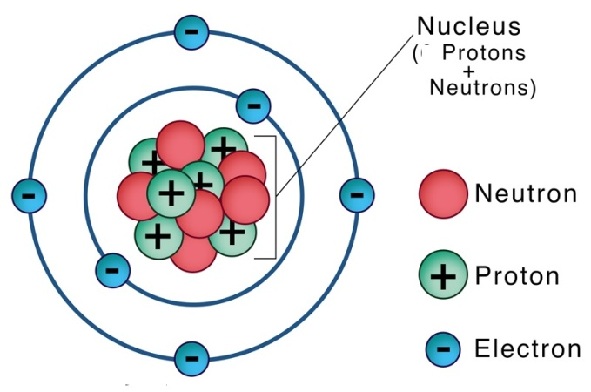

**Sources of electricity**

A source of electricity is anything that produces electricity.

* dry cell
* Simple cell
* Solar cell
* Battery
* Flowing water
* Sun
* Fossil fuels
* Tidal waves
* Steam from hot rocks
* uranium

**Note:**

Electrical energy is the form of energy carried by electric currents.

**Electric cells**

An electric cell is a device that produces electric current by chemical reaction.

**Types of cells** (Real object (dry cells)

1. Primary cells
2. Secondary cells/accumulators/storage cells

**Primary cells**

These are electric cells that are not recharged once used.

**Examples of primary cells**

* Dry cell
* Simple cell

**Dry cell**

A dry cell is an electric cell. It stores chemical energy.

**Structure of a dry cell**

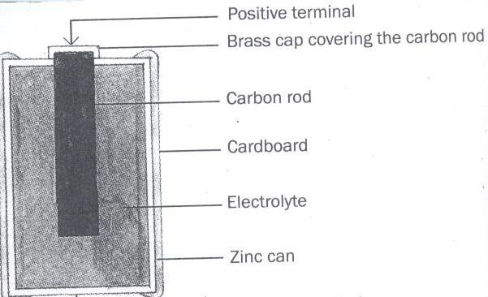

**Functions of each part of a dry cell**

**Bras cap**

It acts as the positive terminal and contact.

**Carbon rod**

It is a non metallic conductor of electricity.

**Electrolyte**

A liquid that conducts electricity

**Zinc can**

A container in which the dry cell content is put and it acts as a negative terminal.

**Insulating top seal**

It prevents the jelly from drying up.

**N.B**: . A dry cell has a voltage of 1.5 volts

The energy needed to push an electric current through an electric circuit is called voltage. Voltage is measured in volts.

A dry cell stores chemical energy. When it is functioning, the chemical energy is changed into electrical energy.

The energy change that takes place in a dry cell is chemical energy changes to electrical energy.

A dry cell has two terminals the positive terminal and the negative terminal.

**Exercise**

1. Juliet’s radio uses **seven** dry cells.

How many volts are needed if he is to use it to listen to news?

1. How is the carbon rod useful in a dry cell?
2. Suggest any one cause of dry cells losing their energy.
3. Give any two ways you can conserve electricity at home.
4. Identify any one source of electricity.
5. Suggest any three uses of electricity at home.

**LESSON 10**

**Content: Simple cell (Wet cell)**

(Pratical: Materials; electric wires, bulb, copper and zinch rods)

It consists of a zinc plate and a copper plate dipped in dilute sulphuric acid.

The zinc plate acts as the **negative** pole called the cathode.

The copper plate acts as the **positive** pole called the anode.

**Acid acts as the electrolyte**

The zinc and copper are called **electrodes**

**An electrode** is a piece of metal that allows electric current to pass through it when placed in an electrolyte.

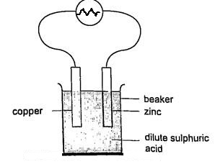**Illustration**

The bulb connected across the cell, begins to glow but after only a few minutes it becomes dimmer until it finally lights off. This is because of two main factors. i.e.

1. polarization
2. local action

**Polarization**

**Polarization** is when bubbles of hydrogen cover them copper rod. This stops the flow of electrons and fails the cell to work.

**Local action**

**Local action** is when bubbles of hydrogen are seen coming off the zinc rod. This happens due to the presence of impurities in the zinc plate.

**A homemade simple cell** (Practical materials needed: lemon, copper and zinc

A homemade simple cell is made using an orange, grape or lemon juice, copper and zinc plates are dipped into an orange or lemon and a wire is connected on the bulb.

The lemon / orange juice is what acts as the electrolyte

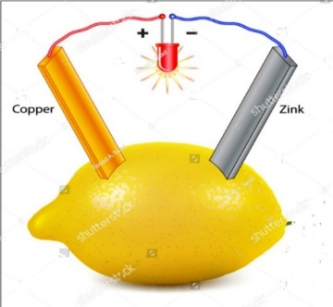

**Illustration**

**Disadvantages of using a wet cell**

1. It is bulky
2. It can only be used in an upright position.
3. It works for a short time

**Exercise**

1. What is the importance of the dilute sulphuric acid in a wet cell?
2. Why are wet cells grouped under primary cells?
3. State one disadvantage of using wet cells?
4. What acts as the electrolyte in a locally made wet cell?
5. Give one advantage of using a dry cell over a wet cell?

**LESSON 11**

**Content: Secondary cells**

These are electric cells that can be recharged when they get exhausted.

The following are examples of secondary cells

* Car battery
* Solar battery
* Phone battery

**The car battery**

A Car battery is an example of a secondary cell.

It has the positive (+) terminal {anode} and a negative (-) terminals {cathode}

The terminals are called **electrodes**

**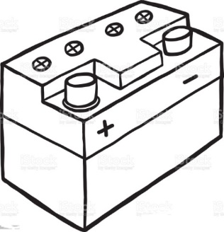**

**Uses of a car battery**

* It is used to start a car
* It produces electricity used to light the headlamps**.**

**Advantage of using a chemical battery**

It can be recharged and used again when it has run down.

**Fast flowing water**

It turns turbines connected to a generator to produce hydroelectricity.

**The sun**

The sun produces light which is converted into solar electricity using solar cells.

The solar panel contains solar cells

The solar cells trap sunlight energy and convert it into solar electricity.

The solar battery stores solar electricity.

**Fossil Fuels**

Fossil fuels are fuels got from plants and animal remains buried million years ago

Fossils are remains of plants and animal remains buried million years ago.

Fossil fuels used in production of electricity are coal, petrol and diesel.

**Coal / oil** can be burnt to produce Thermal electricity.

Coal stores chemical energy.

**Petrol and diesel**

Theseare used to run fuel generators.

The main difference between coal and petroleum is that coal is a solid while petroleum is a liquid.

**Uranium**

It is burnt to produce nuclear energy.

Uranium stores chemical energy.

**Wind**

The wind turns windmills to produce electricity.

**Exercise**

1. Name any three sources of electricity.
2. Which form of electricity is produced by burning fossil fuels?
3. How is the sun useful in the environment?
4. How is wind able to produce electricity?
5. Give one difference between wind and air.
6. State any one example of a fossil fuel.

**LESSON 12**

**Content: Types of electricity**

There are two main types of electricity; these are;

1. static electricity
2. current electricity

**Current electricity**

This is the type of electricity where there is flow of electrons.

Current electricity flows from the source to the appliance through a conductor.

An appliance is anything that uses electricity.

**The following are examples of electric appliances**

* electric bulb
* flat iron
* refrigerator
* cooker
* television
* radios

**The diagram showing the flow of current/ electricity/ electric current**

(Practical : Material; bulb, dry cells conducting wire)

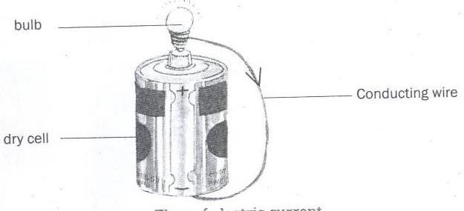

**The diagram showing the flow of electrons**

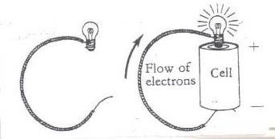

**Types of current electricity**

**Direct current (DC)**

This is a type of current electricity where the current flows in one direction i.e. from the source to the appliance.

Sources of direct current electricity include; chemical batteries and dry cells.

**Alternating Current (AC)**

This is a type of current electricity where current flows in two directions i.e. from the source to the appliance and then back.

**The sources of alternating current electricity are;**

* Fast flowing water
* Tidal waves
* Steam from hot springs
* Uranium

**Forms of electricity**

1. **Hydro electricity**

Hydro electricity is a form of electricity produced from fast flowing water turning turbines at a dam.

1. **Thermal electricity**

Thermal electricity is a form of electricityproduced by burning fossil fuels.

1. **Solar electricity**

Solar electricity is a form of electricity produced from the sun.

1. **Nuclear electricity**

Nuclear electricity is a form of electricityproduced from uranium

1. **Geo thermal electricity**

Geothermal electricity is a form of electricity produced from the steam of hot rocks in the earth’s crust.

**Exercise**

1. Write down the two types of electricity.
2. State any two forms of electricity.
3. Draw a diagram to show flow of electricity
4. What type of electricity is commonly used by most people in urban areas in Uganda?
5. Briefly state the meaning of the term alternating current.

**LESSON 13**

**Content: Conductors and insulators of electricity** (Real; objects- iron nails, plastics , paper)

Conductors of electricity are materials that allow electricity to pass through them.

**Examples of conductors of electricity**

1. silver
2. iron
3. copper
4. lead
5. steel
6. aluminium

**Note:**

1. Silveris the best conductor of electricity.
2. Copper and aluminium are commonly used because they are cheap.
3. Silver is not commonly used to make electric wires because it is very expensive.

**Electrolytes**

These are liquid conductors of electricity.

Examples of electrolytes include;

* undistilled water
* acids

**Note**

Undistilled water contains mineral salts that conduct electricity.

Wet wood conducts electricity because it has water with mineral salts.

Distilled water does not conduct electricity because it lacks mineral salts.

**Insulators of electricity**

These are materials that do not allow electricity to pass through them easily.

**Examples of insulators;**

Rubber, plastic, dry wood, dry paper, dries cloth, air and porcelain

**Importance of insulators**

1. They are used to insulate handles of flat irons to prevent burns.
2. They prevent short circuits.

**Exercise**

* + 1. Why are electric wires covered with insulators?
    2. How are insulators useful in the kitchen?
    3. Why is silver not commonly used to make electric wires?
    4. Why are most electric wires made from aluminium?
    5. Give the difference between conductors and insulators of electricity.

**LESSON 14**

**Content: Electric circuit** (practical : teacher should guide chidlrne on how to make a simple electric circuit)

An electric circuit is a path through which an electric current flows.

**Components of an electric circuit**

1. a switch
2. electric bulb
3. a conductor (wire)
4. dry cells
5. ammeter
6. fuse

**Symbols used in an electric circuit**

|  |  |
| --- | --- |
| **Item** | **Symbol** |
| battery |  |
| light bulb |  |
| switch |  |
| fuse |  |
| ammeter |  |
| voltmeter |  |

**A simple Electric circuit**

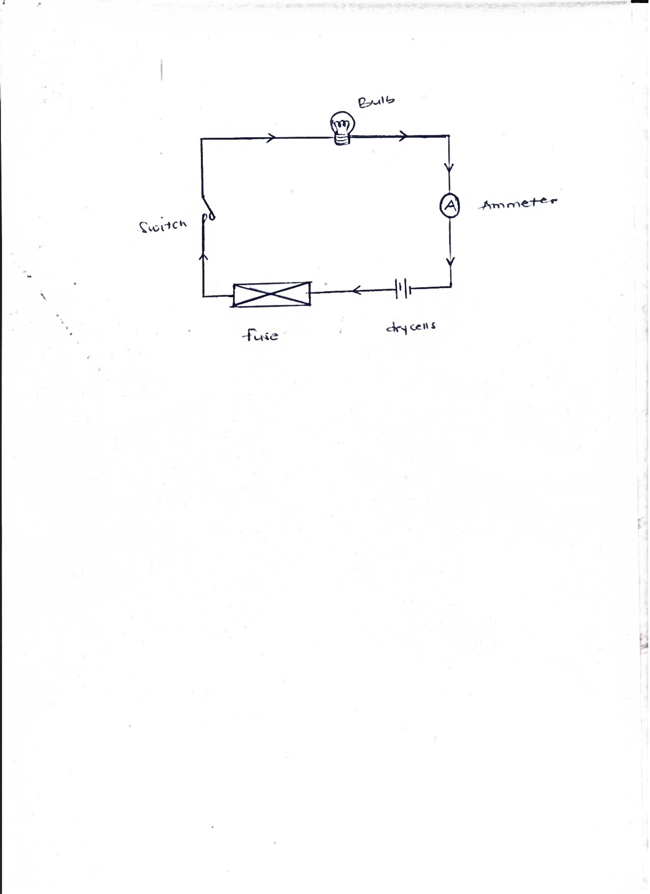 bulb

conductor/wire

switch ammeter

fuse dry cells

**Uses of parts of an electric circuit**

1. **Switch**

This breaks or completes the circuit at the users wish.

1. **Battery/dry cells**

They produce electricity in the circuit.

1. **Conducting wire**

It transports electricity from the source to the appliance.

1. **Fuse**

It breaks the circuit when there is too much current flowing through the circuit.

1. **Bulb**

It gives out light.

**Three pin plug**

A plug is an electric device with two or three pins which is fixed in a socket to make an electrical connection inside a plug is a cable that consists of wires that carry electricity to and from an appliance. Plugs with two pins are called two pin plugs while those with three pins are called three pin plugs

**An illustration of a three pin plug**

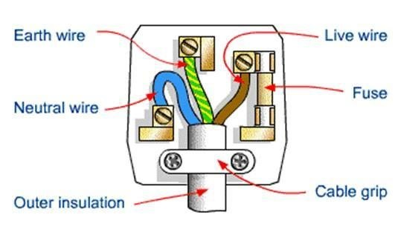

**Uses of each component of a conducting wire**

1. **Earth (yellow or green)**

The earth wire is coloured yellow or green. It minimizes excess current to prevent from electric shocks.

1. **Neutral (Blue/black)**

It takes back current to the source.

It is coloured blue or black .

1. **Live (Red/brown)**

This is coloured red and brown.

It brings current from the source to the appliance

**Insulation** prevents electric shocks.

**Exercise**

1. How are the following important in a circuit?
2. switch
3. fuse
4. How is a fuse similar to a switch?
5. How is a red wire useful in an electric circuit?
6. How is an electric bulb useful in a circuit?
7. How does a fuse work?

**The torch/flash light**(Real object ; ordinary torch, dry cells)

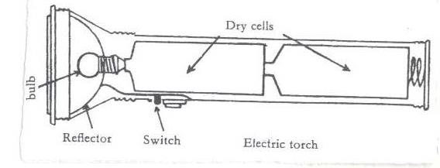

**Uses of parts of a torch**

**Reflector**:

Itdirects lights into a parallel beam of light.

**Bulb**

It produces light.

It changes electric energy to heat then to light.

**Dry cells**

It is the source of electric energy.

**Glass**

It protects the bulb and reflector.

**Switch**

It breaks and completes the circuit at the users wish.

**Cover and springs**

They keep the dry cells tightly together.

**Exercise**

1. State the use of a torch to people.
2. How are dry cells useful in a dry cell?
3. How can the brightness of a torch be increased?
4. How is a reflector useful in a torch?
5. How is the glass useful in a torch?
6. How are the following important in a circuit?
7. Switch
8. Fuse
9. How is a fuse similar to a switch?
10. How is a red wire useful in an electric circuit?
11. How does a fuse work?

**LESSON 15**

**Content: The Electric Bulb (**Real objects; ordinary bulbs)

An electric bulb produces electricity in a circuit.

**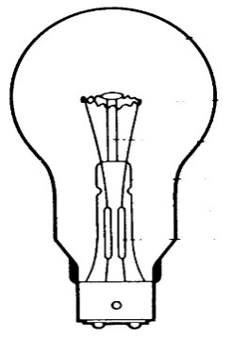**

glass envelope

filament

filament support

brass cap sealing tube

contacts

**Functions of some parts**

1. **Filament**

The filament produces light

It is made of **tungsten** from a mineral called **wolfram.**

**Adaptation of the filament for its function**

1. It has a high melting point.
2. It is coiled to increase electric resistance
   1. **Conducting wire**

It conducts electricity to the filament.

* 1. **Glass envelope**

It protects the inside parts of the bulb.

It prevents nitrogen and argon gases from escaping.

It is transparent to allow light to pass through.

* 1. **Filament support**

It supports the filament.

* 1. **Contact**

It allows electricity into the bulb.

**Gases found in an electric bulb**

* argon
* nitrogen

**Argon**

It prevents darkening of the glass envelope

**Nitrogen**

It prevents evaporation of tungsten.

**Exercise**

1. Why is a filament of an electric bulb coiled?
2. State any component of a circuit that uses an alloy.
3. How is the reflector important in an electric torch?
4. Which gas is commonly used in electric bulbs?
5. Give one reason why the glass of a bulb is transparent?

**LESSON 16**

**Content: Short circuits;** (Practical; Material; bulbs, dry cells and wires

A short circuit is a path of low resistance towards flow of current through circuit.

The main cause of short circuit is contact of two naked wires carrying electricity.

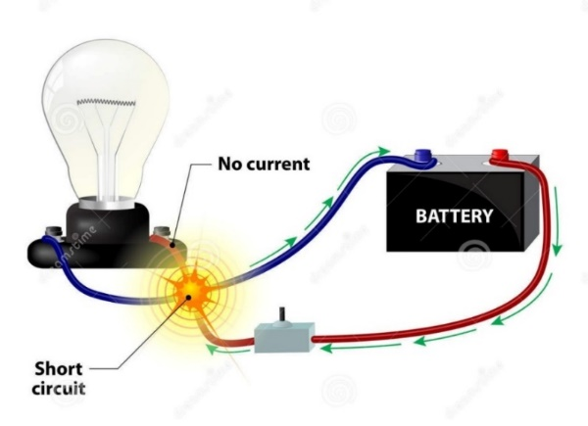

**Conditions that may lead to short circuits**

1. Poor wiring when installing electricity in buildings.
2. Pushing metallic objects in electric sockets.
3. Dampness n the circuit
4. Use of very old wires during wiring.
5. Wrong connection of wires in electric equipment.
6. Overloading sockets.

**Signs of short circuits**

* Smell of burning wire
* Failure by appliances to work
* Shock from appliances
* Smoke from an electric circuit

**Effects of short circuit**

* They lead to destruction of electrical equipment.
* They lead to fires that may burn the building.
* They lead to death of people and animals.

**How to avoid short circuit**

* Electric wires should be covered with an insulating material.
* Installation should be done by experts only.
* Repair of electric appliances should be done by experts.

**Exercise**

* + - 1. How are short circuits dangerous?
      2. Give the main cause of short circuits.
      3. State two conditions that may lead to short circuits.
      4. State one way of controlling short circuits.
      5. How can one
      6. tell that there is a short circuit.

**LESSON 17**

**Content: Static electricity** (practical materials ; plastics

**Static electricity** is the type of electricity where there is no flow of electrons.

It is formed when two insulators are rubbed against each other.

Static electricity is produced by friction.

In nature static electricity can be seen when lightning occurs.

**Lightning**

This is a form of static electricity in nature.

When a positively charged cloud meets a negatively charged cloud, a huge spark is formed and may pass to the ground.

During the passage of lightning, the surrounding air is heated strongly, expands suddenly and then contracts quickly as it cools.

This air vibrates to produce the sound called **thunder.**

**Advantage of lightning**

Lightning helps to fix nitrogen into the soil. This improves on the fertility of the soil.

**How to prevent effects caused by lightning**

1. Avoid sitting under tall trees when it is raining.
2. Install lightning conductors on buildings.
3. Avoid holding umbrellas with metallic handles when walking under rain.
4. Switching off electrical appliances during rain
5. Avoid walking barefooted during rain.

**How lightning conductors reduce risks to the building.**

They provide a route for electrons to pass into the ground without damaging the building.

**Differences between static electricity and current electricity**

|  |  |  |
| --- | --- | --- |
|  | **Static** | **Current** |
| 1 | Takes place in insulators. | Takes place in conductors. |
| **2** | The charge is on the surface. | Charge is inside the conductor. |
| 3 | The charge does not flow. | Charge flows through the conductor from one place to another. |

**Importance of electricity**

1. It is used for cooking
2. It is used for lighting
3. It is used to run machines
4. It is for ironing
5. It is used for washing

**Advantages of using electricity over other forms of energy**

1. It is quick.
2. It is easy to use.
3. The use of electricity conserves the environment.

**Disadvantages of electricity**

1. It is expensive to install.
2. Electricity can shock and cause death.
3. It can burn buildings.

**Safety precautions in handling electricity and electrical appliances**

1. Never touch a switch with wet hands
2. Avoid over loading the socket.
3. Avoid repairing the appliance when not trained.
4. Avoid pushing metallic objects into sockets.
5. Never open anything that uses electricity if not an expert.
6. Never touch an electric wire that has fallen from an electric pole.
7. Never take shelter under tall trees during thunderstorm.

**Exercise**

1. What is static electricity?
2. Name the force that helps in the production of static electricity.
3. How can the effects of lightning be prevented in your home?
4. State two differences between static and current electricity.
5. Give two advantages of using electricity.
6. Why is it bad for a P7 candidate to push metallic objects into sockets?

**LESSON 18**

**Content: Magnetism**

Magnetism is the property of a magnet which enables it to attract or repel magnetic materials

**Magnet**

A magnet is a piece of metal that attracts or repels magnetic materials. Materials that can be attracted by a magnet are called magnetic materials.

**Examples of magnetic materials**

* iron
* nickel
* cobalt
* steel

**Nonmagnetic substances**

These are substances that cannot be attracted by magnets.

**Examples of nonmagnetic substances**

* dry wood
* plastic
* lead
* glass
* cloth
* copper
* paper
* aluminium
* brass

**Types of magnets** (Real objects (magnets)

There are two main types of magnets. These are

1. Artificial magnets
2. Natural magnets
3. **Artificial magnets**

These are magnets made by people. They are made in different sizes and shapes.

**Examples of artificial magnets**

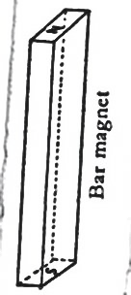**Bar magnet**

This is a bar of uniform cross section. It may be rectangular or circular.

**Structure of a bar magnet**

**Horse shoe magnet**; It has a U shape.

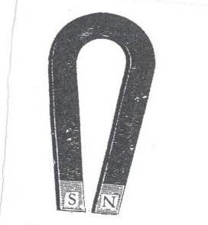

**Needle magnet**; It is thin pointed at both ends and balanced at the centre.

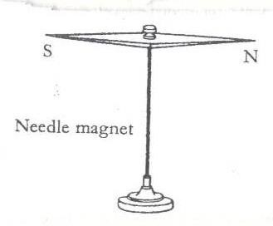

**Electromagnet**

This is a magnet made using electricity. It is a temporary magnet which only works in the presence of electricity.

**Illustration**

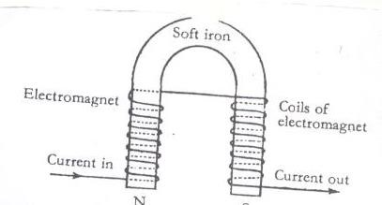

1. **Natural magnets**

These are materials that exist by nature and attract magnetic materials. There are two main examples of natural magnets. These are

1. The earth
2. lodestone

**The Earth**

It is a huge natural magnet. Its magnetic field is weak, that is why you can’t feel it.

The earth is a magnet because it has both the north and south poles. The poles of the earth are called geographical poles.

**Illustration**

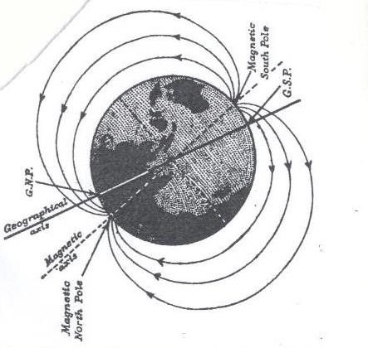

**Lodestone**

Lodestone is a magnetic ore which occurs naturally in the earth. It was discovered near the ancient city of magnesia in Asia Minor. It was the first magnet to be discovered by people.

**Exercise**

1. Name two examples of natural magnets.
2. Name the two types of magnets.
3. Cite out any two examples of magnetic materials
4. Why is the earth said to be a magnet?
5. Why can’t copper be attracted by a magnet?
6. Why is it difficult to separate nails from iron filings?

**LESSON 19**

**Content: Properties of magnets**

A property of magnets is a behavior/ characteristic of magnets. There are several properties of magnets. These include;

1. Like poles of magnets repel whileunlike poles of magnets attract each other.

**Illustrations**

1. Like poles of magnets repel.

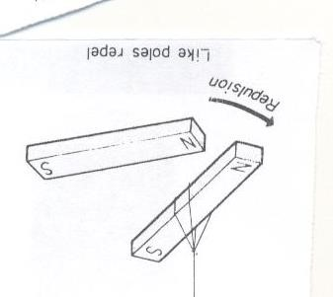

1. Unlike poles attract each other.

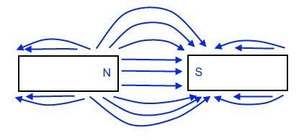

1. A freely suspended magnet rests in the north to south direction.

This property is used in compasses to show direction of places. This is because the north pole of the magnet is attracted by the south pole of the earth while the south pole of the magnet is attracted by the north pole of the earth.

**Illustration**

**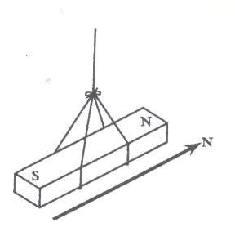**

1. 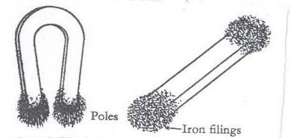Magnetism is stronger at the poles of a magnet.
2. Lines of force on a magnet run from the north to south direction. This property forms a magnetic field around the magnet.

A magnetic field is a region around a magnet in which lines of force act.

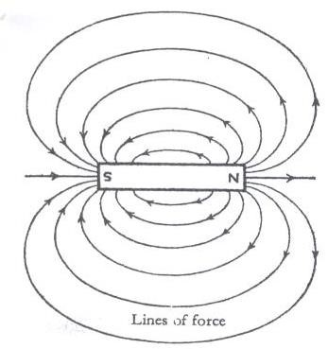**An illustration showing a magnetic field**

1. Magnetism can pass through non magnetic materials. This property enables doctors to remove iron materials from patients’ bodies.

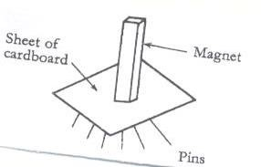

1. When a magnet is broken, each piece becomes an independent magnet.

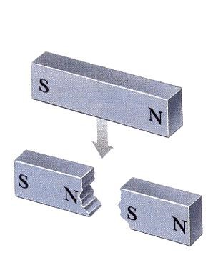

**Exercise**

1. Which property of magnets is used by a pilot to locate places?
2. How are magnets useful to doctors?
3. What do we call the region around a magnet in which magnetism is felt?
4. How do iron keepers prevent magnets from losing magnets?
5. What happens to the pieces when magnets break?

**LESSON 20**

**Content: Law of magnets and magnetization**

The law of magnets states that like poles of magnets repel each other while unlike poles attract each other.

**Magnetization**

This is the process of forming magnetsfrom magnetic material

**Methods of making magnets**

There are three methods of making magnets

1. stroking method
2. induction method
3. electrical method

**Stroking method**

This is the process of passing a magnet over a magnetic material to become a magnet**.**

There are two types of stroking

1. Single touch stroking method.
2. Double touch stroking method.

**Single touch stroking method**

It is called stroking by single touch method because one magnet is used.

The end of a material last stroked becomes the opposite to the pole of a magnet being used.

**Illustration**

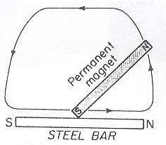

**Stroking by double touch**

This is where two magnets are used to stroke a magnet.

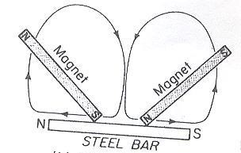**Illustration**

**Induction**

This is where a magnetic material is brought into contact with a magnet in order to gain magnetism. The magnet formed using this method is called an induced magnet.

**Illustration**

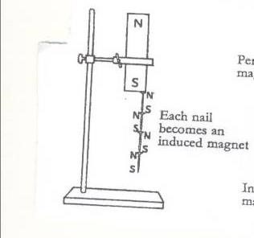

**Exercise**

1. What is magnetization?
2. Name two examples of temporary magnets.
3. What name is given to the magnet formed by induction?
4. Give three methods of forming magnets.
5. Why are the poles of magnets painted with different colors?

**LESSON 21**

**Content: Electrical method**

This is a method of making magnets using electricity.

A magnet made by using electricity is an **electro- magnet**

**Illustration**

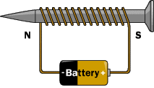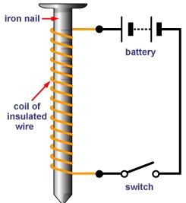

**Determining the poles of an electromagnet**

We can determine the pole of an electromagnet in two ways;

1. **The direction of flow of current.**

Looking at it from either end, if current flows in an anticlockwise way through the solenoid, the pole is North **(N)**

If current flows in a clockwiseway through the solenoid, the pole is South(S).

1. **Using the right hand grip rule.**

Grasp the solenoid in the right hand with thumb pointing in the direction of current**.** The thumb points tothe North Pole

**Electro magnets are made stronger by;**

1. Increasing the number of turns in a coil around the soft iron
2. Increasing the voltage (electrical strength)

**Demagnetizing a magnet**

This is the making of a magnet lose its magnetism.

It is weakening or destroying a magnet

**Ways of demagnetizing a magnet**

1. Hammering/hitting a magnet strongly.
2. Strongly heating a magnet.
3. Leaving a magnet in an east-west direction for a very long time.
4. By keeping the magnets with like poles together.
5. By passing an alternating current through a magnet.
6. Leaving it to rust.

**How to prevent a magnet from losing magnetism**

1. Keep magnets resting in north south direction
2. Keep magnets with unlike poles facing each other
3. Keep magnets in iron keepers

**Magnets kept in iron keepers**

**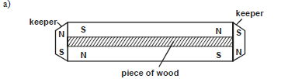**

**How an electric bell works**

1. When the contact is made the soft iron becomes magnetized.
2. It pulls the soft iron strip with the hammer.
3. The hammer hits the gong producing sound.
4. When the strip is pulled the soft iron loses its magnetism and the contact is broken because current is not flowing.

**Exercise**

1. What is demagnetization?
2. State two methods of weakening magnets.
3. How can magnets be prevented from losing magnetism.
4. Which magnet is formed by electrical method?
5. How can you increase the strength of magnets formed by electricity?

**LESSON 22**

**Content: Uses of magnets**

People use magnets in different ways and some of them are as below.

1. Magnets are used in compasses to show direction
2. Electromagnets are used in industries to lift heavy scrap iron metals
3. Magnets are used in electric bells.
4. They are used in loud speakers.
5. They are used on doors of fridges.

**Appliances that use electricity**

1. flat irons
2. heaters
3. driers.
4. washing machines
5. electric fans
6. cooker

**Appliances that use magnets**

1. Magnetic compasses.
2. Magnetic tapes.

**Appliances that use both electricity and magnetism**

1. fridges
2. radios
3. televisions
4. mobile phones
5. electric bells

**An Electric bell**

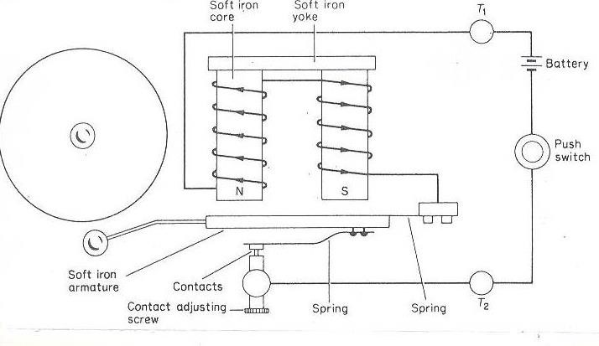

1. How are magnets used at a construction site?
2. How are magnets useful at school?
3. How can the strength of magnets be increased?
4. Name three ways magnets lose magnetism?
5. How is an electric bell useful at school?

**LESSON 23**

**Content: Devices connected to electricity**

**Dynamo**

A dynamo is a device which converts mechanical energy intoelectrical energy. A dynamo uses a permanent magnet and a coil of wires on electro magnets

During the turning, the mechanical energy is turned into electrical energy**.**

**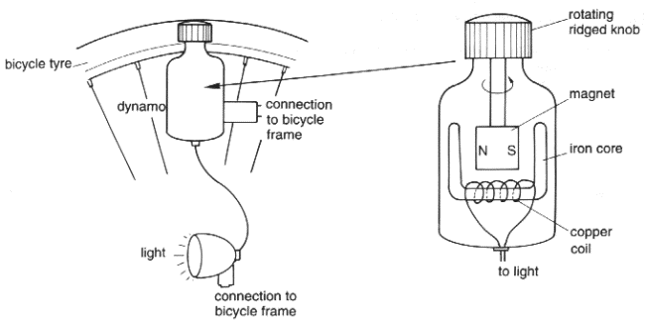Parts of a dynamo**

A simple kind of dynamo can be found on a bicycle and bigger ones in vehicles.

Those in vehicles are used for recharging batteries.

On a bicycle, a dynamo is used to produce electricity for lighting. It is connected on the hind wheel with the knob touching the bicycle tyre.

When one is riding, the tyre rotates the knob of the dynamo which turns the magnet in a strong magnetic field and produces electricity. Electricity moves through the conducting wire to the head lamp which produces light.

One can increase the brightness of the bulb by riding/peddling faster and reduce the brightness by peddling slower.

**A dynamo on a bicycle**

****

**Generator**

A generator produces alternating current electricity.

It changes mechanical energy to electrical energy**.**

**A generator**

**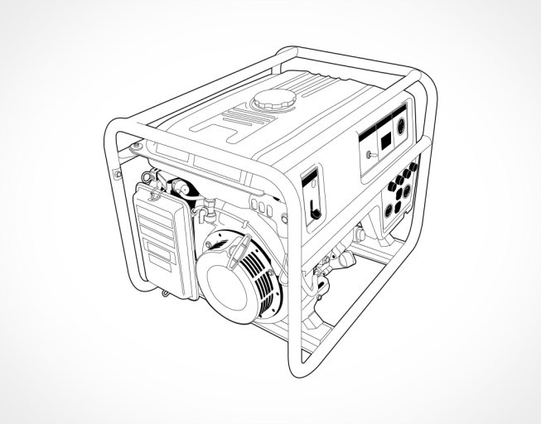**

A generator can be made to produce more electricity by;

1. Increasing the number of turns in a coil.
2. Increasing the strength of the magnetic field.
3. Increasing the speed of rotation.

**Uses of dynamos and generators**

1. They provide electricity for light.
2. They provide energy to run machines.
3. They provide energy for cooking

**Exercise**

1. How is magnetism different from magnets?
2. State any one law of magnetism.
3. How are magnets important to the following?
   1. doctors
   2. pilots
4. Name one item that uses both magnets and electricity.
5. In four sentences, briefly explain how an electric bell works.
6. What is the importance of the hammer found on an electro magnet?
7. State one way of making magnets.
8. In which one way can a P.7 child make a magnet lose its magnetism?

**LESSON 24**

**Topic: Energy resources in the environment**

**Energy**

Energy is the ability to do work

**A resource**

This is anything that people use to satisfy their needs.

**Types of resources**

There are two types of resources. These are;

1. Renewable resources
2. Nonrenewable resources

**Renewable resources**

These are things that can be replaced naturally when used up.

**Examples include;** Plants, animals, land (soil), water, air, sun.

**Nonrenewable resources**

These are things that cannot be replaced naturally when used up.

Examples: rocks, gold, copper, petroleum, coal, natural gas etc.

**Energy resources**

An energy resource is anything that provides people with useful energy.

**Examples of energy resources**

1. sun
2. water
3. coal
4. air or wind
5. plants
6. animals
7. petroleum
8. uranium
9. natural gas etc

**Types of energy resources**

Energy resources are grouped into two. These are;

* 1. Renewable energy resources
  2. Non renewable energy resources

**Renewable energy resources**

A renewable energy resource is an energy resource which can be replaced naturally once used up.

**Examples of renewable energy resources**

1. water
2. sun
3. animals
4. plants
5. air/ wind

**Nonrenewable energy resources**

These are resources which cannot be replaced once used up

**Examples of nonrenewable resources include;**

Coal, petroleum, natural gas, peat, plutonium etc.

**Exercise:**

1. How is a resource different from an energy resource?
2. Write two examples of renewable energy resources.
3. Why is coal regarded as a nonrenewable energy resource?
4. In which way is water as a renewable resource replaced?

**LESSON 25**

**Content: Water as an energy resource**

Water is used by people as an energy resource in the following ways;

1. Fast flowing water is used in the production of hydro electricity
2. Water tides of the sea are used to produce tidal energy
3. Steam from hot water is used to run steam engines
4. Water is used to cool machines in industries.

**Hydro electricity**

This is a form of electricity produced by the power of fast flowing water at a fall. It is also called hydroelectric power (HEP)

**How HEP is produced** (Audio-visual)

* Power dams are built with wheel like structures called turbines which are connected to generators with strong magnetic fields.
* Water is held at the back of the dam (in the reservoir)
* The water level at the reservoir is higher than that below the dam
* The water in the reservoir flows across the turbines which rotate causing generators to start hence producing electricity.

**Note:**

The water in the reservoir possesses potential energy

Potential energy changes to kinetic energy when water flows from the reservoir across the turbines

Kinetic energyturns the turbines connected to a generator with powerful magnetic field and a coil of wire turning it. In this way HEP is produced.

**An illustration of a hydro electric power plant**

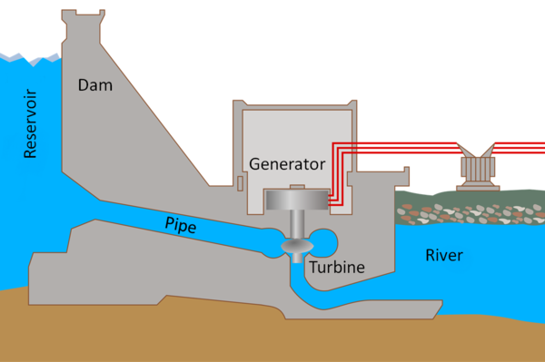

Dynamo

Long distance power lines

**Exercise**

1. State two reasons why water is regarded as an energy resource.
2. Identify the form of electricity produced by the power of flowing water.
3. State two energy changes that take place during the production of hydro electricity
4. Write HEP in full.
5. How does electricity from the dam reach all parts of the country?
6. How does the use of hydroelectricity for cooking contribute to the conservation of our environment?

**LESSON 26**

**Content: Tidal energy** (audio visual)

This is the form of energy got from **water tides** on the sea shores.

Tides are periodic rises and falls of water in large water bodies.

The tides are caused by gravitational interaction between the earth and the moon.

Water that rises is trapped in to the dam where there are turbines. The water rotates turbines which turn generators and produce electricity

**Steam**

Steam is hot vapour got when water boils and begins to evaporate. It is very hot and moves at a very high speed. It has the ability to move things because it possesses kinetic energy.

Steam is used to run steam engines

Machines with steam engines include; steam boats, steam trains and steam ships.

**A steam ship A steam boat A steam train**

**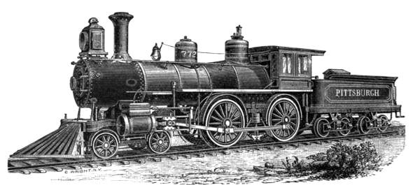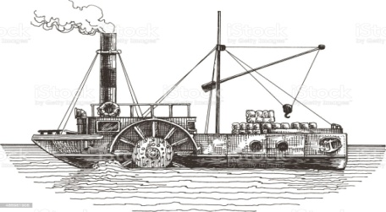**

**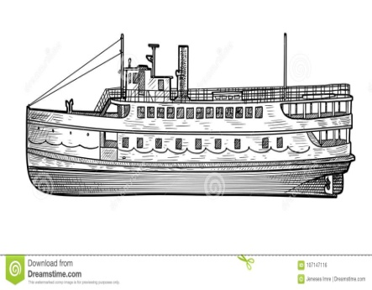**

**Geothermal electricity** (Audio visual)

This is a form of electricity got from hot springs. A hot spring is a spring produced by the emergency of heated underground water onto the surface of the earth.

The under ground water is heated by molten rocks (magma).

Steam from the hot springs is used to rotate turbines causing generators to start and produce electricity.

This form of electricity is not commonly used in Uganda because it is expensive.

**Exercise**

1. What is a tide?
2. What causes tides on water bodies?
3. What type of energy is possessed by steam?
4. State any one way steam can be useful to people?
5. Which form of electricity is got from hot springs?
6. **Complete the table below correctly**

|  |  |
| --- | --- |
| **Form of electricity** | **Source** |
| **\_\_\_\_\_\_\_\_\_\_\_\_\_\_\_\_\_\_\_\_\_\_\_\_\_\_\_\_\_\_\_\_\_\_\_\_** | Fast flowing water |
| Tidal electricity | \_\_\_\_\_\_\_\_\_\_\_\_\_\_\_\_\_\_\_\_\_\_\_\_\_\_\_\_\_\_ |
| \_\_\_\_\_\_\_\_\_\_\_\_\_\_\_\_\_\_\_\_\_\_\_\_\_\_\_\_\_\_ | Hot springs |
| Solar electricity | \_\_\_\_\_\_\_\_\_\_\_\_\_\_\_\_\_\_\_\_\_\_\_\_\_\_\_\_\_ |

**LESSON 27**

**Content: The sun**

The sun is the main source of heat and light on earth.

**Importance of the sun as an energy resource**

1. The sun helps in rain formation.
2. The sun provides heat used in preservation of our food.
3. Light energy from the sun helps the human skin to make vitamin D
4. Light from the sun helps us to see.
5. Light from the sun is used to produce solar electricity.
6. Light from the sun enables plants to make food.
7. Heat from the sun dries our clothes.

**Solar energy**

This is a form of energy got from the sun. People make use of solar energy in various ways. Some use it to produce heat for drying crops, heating water etc.

Others use it to produce electricity.

Several devices are used to put solar energy in to use. These include; solar panels, solar water heaters, solar driers and solar cookers

**A solar panel** (Out of class lkesson)

A solar panel is device that converts sunlight energy into solar electricity. It has solar cells which convert sunlight energy into solar electricity.

The electricity can be stored in solar batteries or used directly by the solar electric devices

**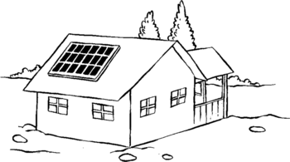Structure of a solar panel**

**A solar panel on the roof**

**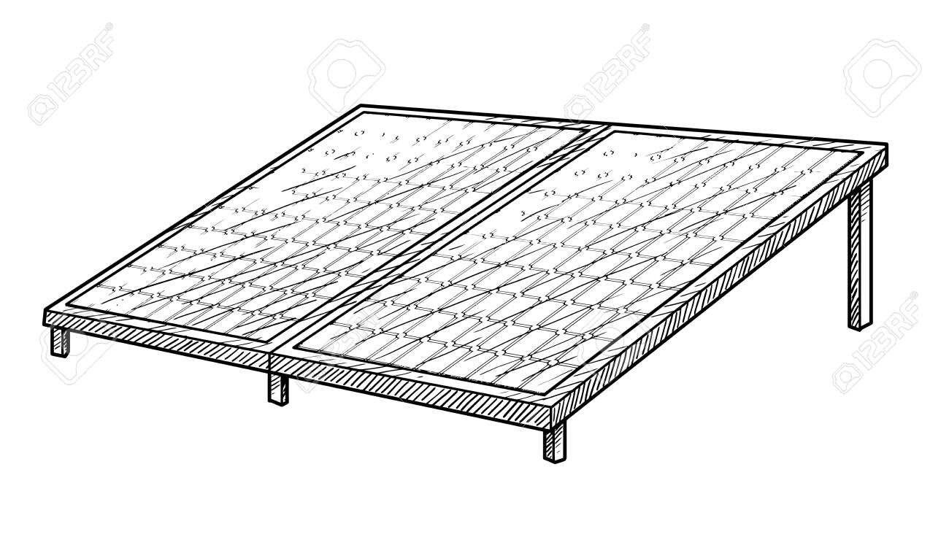**

**Note:**

1. Solar panels are placed on top of roofs in order for them to get enough sunlight.
2. They are painted black to absorb more heat and light from the sun.

**Exercise**

1. What is the main natural source of heat to the environment?
2. How is the sun useful as an energy resource to people?
3. What form of electricity is got from the sun?
4. How is the sun useful in the production of solar electricity?
5. Why are solar panels;
6. Put on roof tops?
7. Painted black?
8. Why would you encourage people to use solar electricity?
9. State any one problem associated with the use of solar electricity

**LESSON 28**

**Content: Solar cooker, solar drier, solar water heater** (Audio visual –text book teaching)

A solar cooker is used for cooking. It uses heat from the sun

It is put under sunshine when cooking.

**Structure of a solar cooker**

**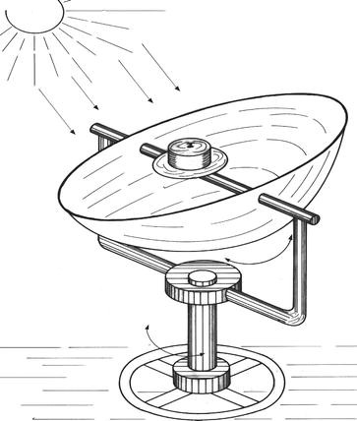**

Cooking pan

reflector

**Functions of some parts**

1. **Cooking pan**

It conducts heat to the food being prepared

1. **Reflector**

It reflects heat from the sun to the pan

**Solar water heater**

A solar water heater uses heat from the sun to warm water

Solar water heaters are also painted black to absorb more heat from the sun

**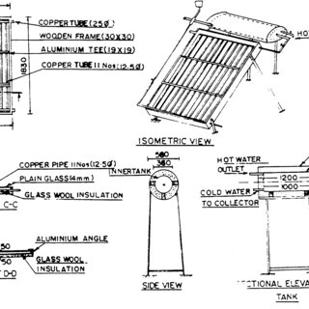Structure of a solar water heater**

Inlet

(Cold water in)

Water tank

Outlet

(Warm water out

**A solar drier**

A solar drier uses heat fro the sun to dry grains/seeds and sliced fruits

**Structure of a solar drier**

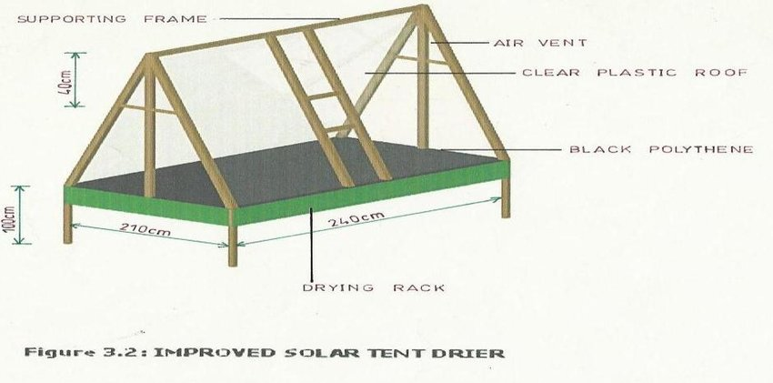

**Uses of solar energy**

Solar energy can be used in various ways these include;

1. It is used for cooking
2. It is used for lighting
3. It is used for running devices like televisions
4. It is used for ironing
5. It can be used for dying seeds.

**Advantages of using solar energy**

1. It does not pollute the environment
2. It reduces on the utility bills
3. It reduces on the consumption of non renewable resources

**Disadvantages of using solar energy**

It can only be used in the presence of the sun

**LESSON 29**

**Content: Animals as energy resources** (Text book teaching / audial visual)

1. Animals provide meat eaten as food by people
2. Some animals are used for ploughing land. Examples are the oxen
3. Some animals for example horses, camels and donkeys are used for transport
4. Some animals are used for pulling carts
5. Animals provide wastes used in the production of biogas

**Horse pulling a cart**

**Donkey carrying a load**

**Oxen ploughing**

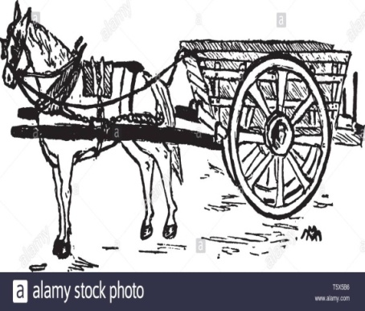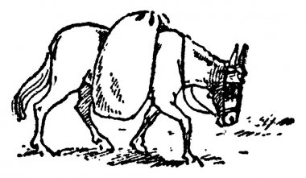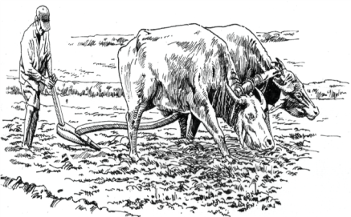

**Plants as energy resources**

1. Plants provide us with food
2. Plants provide people with wood fuel
3. Plants remains are used to produce biogas
4. Plants provide people with biofuels

**Wood fuels**

These are fuels got from plant wood

A fuel is anything that burns to produce heat

**Examples of wood fuels**

* Fire wood
* Charcoal
* Wood shavings
* Saw dust

**Importance of wood fuel**

* It is used for cooking
* It is used boiling water
* It is used for warming ourselves

**Charcoal production**

Charcoal is a black carbon material got after burning wood in a limited supply of oxygen

**Steps taken when making charcoal**

1. Wood is cut into pieces
2. The pieces of wood are piled together to make a kiln
3. Grass is put allover the wood and then covered with soil with one side left open
4. Fire is then set from the open side. When wood catches fire, open end is also covered with grass and soil.

**Illustration of a charcoal kiln**

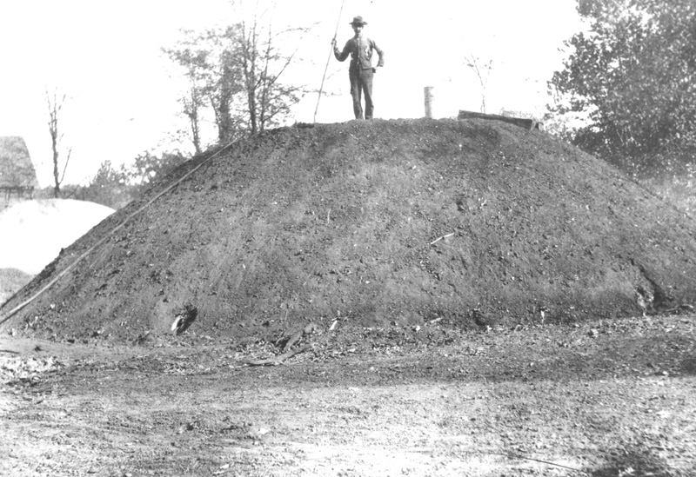

C:\Users\Guest\AppData\Local\Microsoft\Windows\Temporary Internet Files\Content.Word\coal-kiln-for-the-production-of-charcoal-2B1TYMB.JPG

**Dangers of charcoal burning**

1. It encourages deforestation
2. It leads to air pollution since smoke is produced

**Exercise**

1. Write any one animal that can be used for transport.
2. Besides transport, give two other ways animals are used as energy resources
3. Which type of cattle are oxen?
4. State any examples of fuels got from plants
5. How do we obtain charcoal?
6. During charcoal burning, why are pieces of wood covered with soil?
7. What do you think would happen if they weren’t covering them with wood?
8. How is charcoal burning a dangerous activity to the environment?

**LESSON 30**

**Content: Conservation of wood fuel** Real objects: clay made stoves)

Conservation of wood fuel means using wood fuel sparingly without wasting it

This can be done through the following ways

1. By using alternative sources of energy for cooking instead of wood fuel. These can be electricity, biogas, natural gas etc
2. By using energy saving stoves for cooking. These use less fuel (charcoal and fire wood) because they absorb and retain heat for long.
3. By covering food while cooking. This prevents heat from escaping which makes food get ready faster
4. By cutting food into smaller pieces to make it get ready faster
5. By putting off fire after cooking

**Examples of energy saving stoves**

**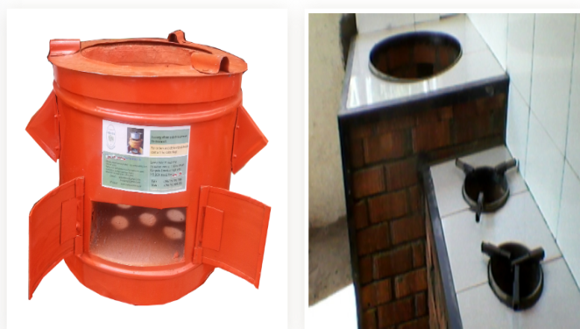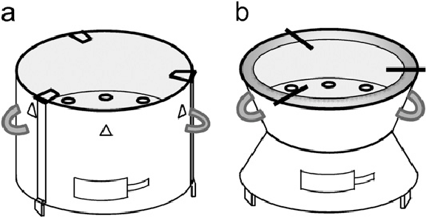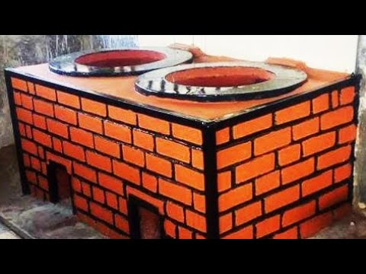**

**Biofuels**

Biofuels are fuels are fuels got directly from living plants and animals

**Examples of biofuels**

There are two main examples of biofuels. These are;

1. Bio diesel
2. Bio ethanol

**Bio ethanol**

This is a liquid made from sugarcane juice through the process of fermentation.

Maize can also be used to make bio ethanol

Bio ethanol can be used as fuel in vehicles

**Bio diesel**

This is a fuel made from vegetable oils and animal fats

It is also used to run engines of some vehicles

**Exercise**

1. Write two examples of wood fuels.
2. Give two ways we can conserve wood fuel at home
3. How does covering food while cooking conserve wood fuel?
4. Write two examples of biofuels

**The diagram below shows a clay made charcoal stove. Use it to answer questions that follow**

****

1. Why is the above stove made of clay?
2. State one advantage of using the above stove over the metallic ones.

**LESSON 31**

**Content: Biogas** (practical / Audio visual)

Biogas is methane that is produced from rotting plants and animal matter.

**Materials used to produce biogas**

1. Animal dung

Animal wastes/ materials

1. Urine
2. Banana peelings
3. Potato peelings

Plant materials

1. Cassava peelings
2. Left over food

**Steps of making biogas**

1. The above materials are put in an air tight container called a biogas digester where they are worked on by anaerobic bacteria to ferment
2. Water is added to the materials in order to speed up the fermentation process
3. During fermentation, the anaerobes(anaerobic bacteria) break the materials producing biogas
4. Biogas is collected in a gas outlet pipe and taken out for use
5. When the gas formation stops, the remains are removed and new ones are put.
6. The remains removed can be used in the garden as manure

**Structure of Biogas digester**

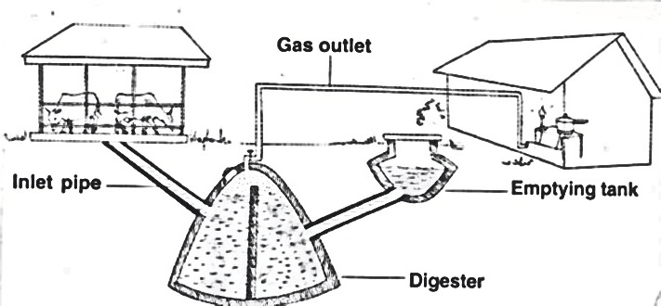

**Uses of the parts**

1. Inlet pipe: it is used for inserting waste matter in to the digester
2. Outlet pipe: it is used for removing the used matter to the garden
3. Emptying tank: it is where the used matter is put before it is taken to the garden
4. Gas outlet pipe: it traps biogas and takes it to where it is used. For example, a gas cooker.

**Note:**

1. Decomposition that takes place in the digester is called anaerobic decomposition. This is because it takes place in the absence of oxygen
2. The biogas digester is tightly covered to prevent entry of oxygen and leakage of biogas.
3. The digester should be buried far from kitchens to prevent explosion of biogas
4. The residue that remains after the collection of biogas is called effluent while the solid one is called slurry( sludge)
5. Biogas is made of mainly methane. It also contains some carbon dioxide.

**Uses of biogas**

1. It is used for cooking
2. It is used for lighting
3. It is used for heating

**Advantages of using biogas**

1. It controls deforestation
2. It does not pollute the air since smoke is not produced
3. It controls the spread of diarrhoeal diseases. This is through putting into use the animal and human wastes that would lead to spread of diarrhoeal diseases.
4. It is very quick (it produces heat immediately when lit).
5. The bi products can be used in the garden as manure.

**Disadvantages of using biogas**

1. It is expensive to set up a biogas digester
2. Its production is very slow in cold conditions
3. The raw materials may not be readily available in some areas.

**Exercise**

1. Identify the gaseous fuel obtained from plant and animal wastes.
2. Why is the use of biogas said to be environmentally friendly?
3. What type of bacteria are responsible for the production of biogas?
4. How does the use of biogas improve people’s health?
5. State any two uses of biogas.
6. Why should a biogas digester be put far from kitchens?

**LESSON 32**

**Content: Wind/ air**

Wind is moving air. Air is a mixture of gases.

Gases which make up air include; oxygen, carbon dioxide, nitrogen and rare gases.

**Importance of wind as an energy resource**

1. Wind sails boats(dhows) on lakes and seas
2. Wind turns wind mills to generate electricity
3. Wind helps in winnowing
4. Wind drives kites, weather balloons and parachutes
5. Wind helps in seed dispersal
6. Wind helps in pollination

**Wind mills** (audio-visual)

A wind mill is a machine that produces electricity using wind.

Wind mills have turbines connected to generators. When wind blows, the turbines rotate causing the generator to start and produce electricity.

The electricity produced can be used for lighting, cooking etc.

**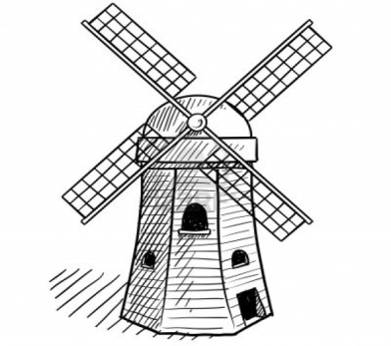Structure of a wind mill**

**Importance of wind mills**

1. They generate electricity
2. They are used to turn water pumps and draw water from underground
3. They are used to mill grains for example maize and wheat

**Using a wind mill to produce electricity**

**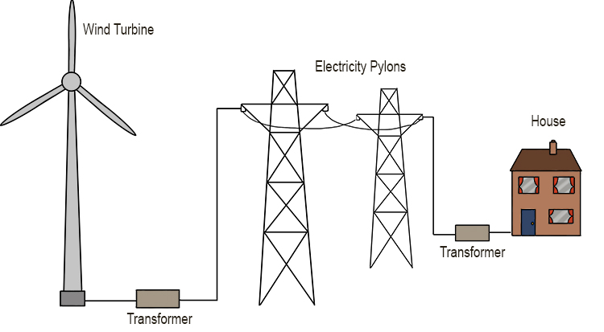**

**Advantages of using wind as an energy resource**

1. It does not pollute the environment
2. The use of wind energy conserves non renewable resources

**Disadvantages of using wind energy**

* wind is not reliable

**Exercise**

1. State the difference between air and wind.
2. Write the component of air with the least percentage in the atmosphere

**The diagram below shows an activity carried out by a crop farmer. Use it to answer questions that follow**

**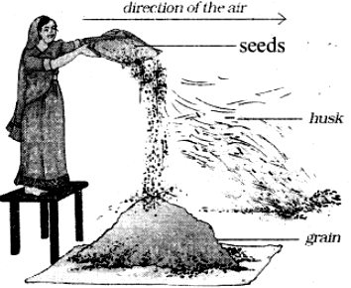**

1. Identify the activity shown in the diagram above.
2. Use an arrow to show the direction from which wind is blowing
3. Besides the above activity, give one other way wind is useful to a crop farmer.
4. Write two advantages of using energy from the sun.

**LESSON 33**

**Content: Energy resources from fossil fuels**

Fossils are remains of plants and animals that were buried million years ago.

Fossil fuels are fuels are fuels got from remains of plants and animals that were buried million years ago.

**Examples of fossil fuels**

1. Coal
2. Petroleum
3. Natural gas

**Coal**

Coal is a black substance mined from underground. It can be burnt to produce heat.

The heat produced can be used for cooking, heating water to produce steam etc.

**Uses of coal**

It is used as fuel in steam engines

It is burnt to produce thermal electricity

It is used for making tar used for surfacing roads

We get coal gas from coal which is used for cooking, lighting etc

**Other products from coal**

Dyes, fertilizers, perfumes, explosives, paints, antiseptics

**Petroleum**

Petroleum is a dark thick liquid found deep in the grounds. It was formed from remains of animals.

After mining, petroleum is taken to the refinery where it processed to get different products.

The products from petroleum include;

* Petrol
* Diesel
* Paraffin
* Jet fuel

These fuels are got from petroleum through a process called **fractional distillation.**

Petrol and diesel are used as fuel to run engines of machines and vehicles. Paraffin is used for cooking and lighting.

**Other products from petroleum**

Grease, Plastics, Tar, Vaseline, Ink, Detergent, Cosmetics, Lubricants, Dyes, Drugs, Insecticides, Fertilizers etc

**Natural gas**

This is a gas got when mining petroleum. When mining petroleum in oil wells, they first come to a layer of gas or the gas may be mixed in petroleum. This gas is got, purified and put in gas cylinders.

This gas is used for cooking and lighting

**A gas cylinder**

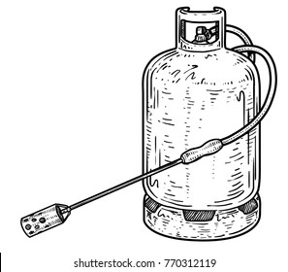

**Note:**

All fossil fuels are nonrenewable energy resources. They cannot not be replaced naturally once used up.

**Other examples of non renewable energy resources include;**

* Uranium
* Peat
* plutonium

**Uranium**

Uranium is a mineral dug from underground. It is burnt to produce electricity in nuclear power stations

Electricity produced by burning uranium is called **atomic/ nuclear electricity**

Uranium is also used to make atomic/ nuclear bombs

It is still used as a fuel in nuclear powered sub marines

**Peat**

Peat is a fuel formed through partial decomposition of plant matter.

It can be burnt to produce heat for cooking. It can also be used in the production of electricity

**Importance of energy resources**

1. They provide support, comfort and help when needed
2. They increase production rates when machines are needed
3. They sustain life

**Exercise**

1. What are fossil fuels?
2. Write any one fossil formed from plants
3. Besides being used as a fuel, give one other use of petroleum to people.
4. What form of electricity is got from burning uranium?
5. Write two examples of non renewable energy resources

**LESSON 34**

**Topic: Machines and friction**

**Content: Forces**

A Force is a push or pull acting upon an object as a result of its interaction with another object.

**Characteristics of forces**

|  |  |
| --- | --- |
| * Forces can cause motion in a body. * Forces can change direction of motion/movement. | * Forces can change size of an object. * Forces can stop motion. |

**Types of forces**

1. Force of friction b. Force of gravity.
2. Force of inertia. d. Force of up thrust /buoyancy force.

**Force of friction**

Friction is the force that opposes movement of objects.

Friction usually occurs between two surfaces which are in contact.

**Situations where friction can be experienced in our daily life** Teacher should demonstrate)

It is always difficult for you to pull or push a table along the floor because there is friction between the table and the floor that opposes the movement of a table as you pull or push it.

Sometimes our doors become difficult to open, or when we are opening, they make some noise. This is because there is friction between the door hinges that prevents them from moving making movement of the door difficult.

**Types of friction**

The type of friction is determined by the position of the objects which are in contact.

This gives us the following types of friction.

1. **Static friction**:

This is a type of friction found between objects fixed in one position. For example a nail fixed in wood

1. **Sliding or rolling friction**:

This is a type of friction found in moving objects. For example in the hinges of a door

1. **Viscosity friction:**

This is a type of friction which occurs in liquids and gases.

It is this type of friction which opposes movement of a fish in water and that of birds in air.

**Properties of friction(**teacher should demonstrate)

* 1. There is more friction with rough surfaces than with smooth or slippery ones.
  2. The greater the load (the weight of an object), the greater the friction force. This means that weight increases friction.
  3. Whenever friction occurs heat is produced.

**Friction as a useful force in our daily life (Uses of friction)**

1. **Friction helps us to write.**

There is friction between the paper and a pen as one writes. This friction enables the pen to grip on the paper and this is how we are able to write. If our books/papers were slippery, the pens would just slide off. This is why if you smear Vaseline on paper, the pen cannot write.

1. **Friction is used in sharpening objects.**

It is friction which enables for example a cutting blade to grip on the pencil as we are sharpening.

Without friction, the blade would be sliding off the pencil.

1. **Friction aids in walking.**

It is because of friction that our feet can get firm on the ground. Without friction, we cannot stand firm on the ground. This is why we slide or even fall on a slippery ground.

1. **Friction helps in lighting match sticks.**

For the match stick to light, you rub it against the match box. Friction opposes motion / movement of the match stick as you rub it against the match box. This is what makes it light.

**Friction as nuisance force/disadvantages**

Friction can be a nuisance in some circumstances. Below are some of the ways friction can be a nuisance

1. **Friction causes wear and tear of objects**

Friction causes wearing of some objects such as rubber, pencils, chalk, shoe soles, car tyres etc. Friction also wears out parts of engines in machines as they move against one another.

1. **Friction delays work**

Since friction opposes motion, one needs to put in more effort to do something and in this process, work is delayed since more time is needed.

1. **Friction produces unnecessary heat in moving objects**

Too much friction causes unnecessary heat in machines. This heat can result into fires.

1. **Friction causes unnecessary noise in moving objects.**

Due to opposition in movement, friction causes noise in moving parts of a machines or objects. This is why door hinges make noise when we are opening or closing doors.

**Exercise**

1. Define the following terms.
   1. Force
   2. Friction
2. Mention any two properties of friction.
3. How is friction helpful to a candidate who is sitting her primary leaving exams?
4. Mention two ways friction can be nuisance to man.
5. Name the type of friction that opposes movement in water.
6. Identify the force that opposes movement in air as a bird flies.

**LESSON 35**

**Content**: **Increasing and reducing friction** (Real objects; shoe, soles, car types, sports shoes, car steerings)

**How to increase friction**

Where friction is useful, it can be increased. Friction is increased by making surfaces rough. This is done through;

1. **Putting treads on vehicle tyres and shoe soles**

The treads increase friction on shoe soles and car tyres which prevents them from sliding.

**Illustrations**

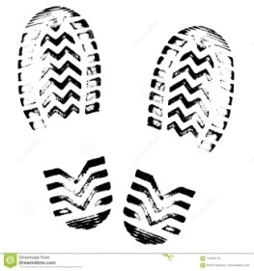

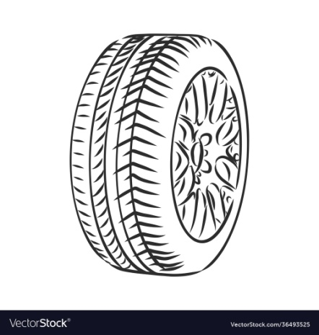

Treads

1. **Putting spikes on sports shoes.**

The spikes increase friction between the shoes and the ground. This prevents the player from sliding.

**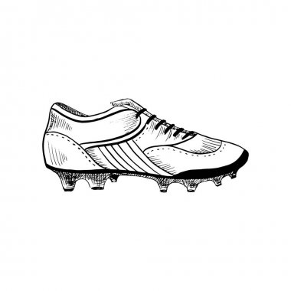A sports shoe**

Spikes

1. **Putting grips on handles of bicycle and car steering wheels**.

Grips are put on handles of bicycles and steering wheels to increase friction so that the hands of the cyclist or driver do not slide off.

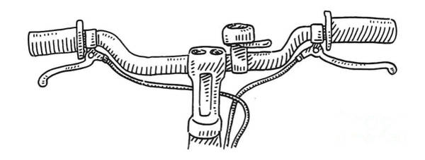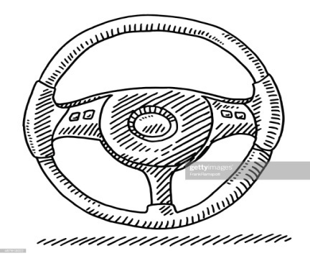**Illustrations**

Car steering wheel

Grips

Bicycle handles

**Ways of increasing friction on a road**

Friction on the road can be increased by;

1. **Tarmacking the road**

Tarmacking is the application of tar mixed with small stones on the road. The mixture of tar and small stones make the road surface rough hence increasing friction between the road and the car tyres.

Tarmacking is one of the permanent ways of increasing friction on roads.

1. **Putting marrum on the road**

Marrum is soil with small rock particles put on roads during construction. The small rock particles in it make the road surface rough hence increasing friction on it.

**How friction can be reduced**

When friction is too much and not wanted, it can be reduced. Below are some of the ways friction can be reduced.

1. **Using rollers** (teacher should demonstrate)

A roller is a cylindrical object that rotates to reduce friction between machines and surfaces.

Rollers reduce friction by preventing contact between two surfaces.

**Illustration**

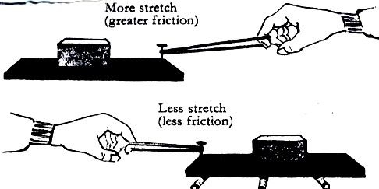

**Rollers**

In the first diagram, it is difficult to move the load on the surface due to much friction.

But when you apply rollers as seen in the second diagram, they reduce contact between the load and the surface. This reduces friction and makes the movement of the load easier.

1. **Using ball bearings**:

These are round metallic balls which reduce friction by keeping moving parts in a machine separate.

**Illustration**

Ball bearings

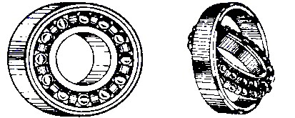

Ball bearings are found in moving parts of machines. They reduce contact between moving parts.

1. **Lubricating**

Lubricating is the use of oil or grease to reduce friction in moving parts of machines. Oil and grease are referred to as **lubricants**. When applied, they (lubricants) make the surface slippery which makes movement in the moving parts of a machine easy.

1. **Streamlining objects**

Streamlining is the making of objects pointed both ends to reduce viscosity (friction in liquids and gases).

**Examples of streamlined objects**

|  |  |  |  |  |
| --- | --- | --- | --- | --- |
|  |  |  | C:\Users\Guest\AppData\Local\Microsoft\Windows\Temporary Internet Files\Content.Word\614-6143524_drawing-knight-spear-transparent-png-clipart-free-download.png | C:\Users\Guest\AppData\Local\Microsoft\Windows\Temporary Internet Files\Content.Word\cruise-ship-260nw-146394236.jpg |
| aero plane | car | boat | spear | ship |

**How friction is reduced in nature**

1. Joints in our bodies have synovial fluid which reduces friction between two bones in contact.
2. Birds, fish and other water animals are streamlined to overcome viscosity. The streamlined shape reduces air/water resistance during the movement of these animals.

**Illustrations showing the streamlined shape of a bird and a fish**

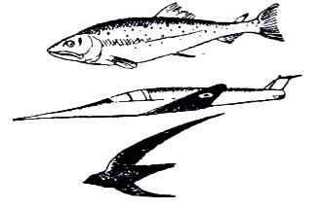

bird fish

**Exercise**

1. State the meaning to the term friction.
2. Cite one way of increasing friction on a slippery surface.
3. Write down any two advantages of friction in our lives.
4. Why is friction said to be a nuisance force?
5. Why are some objects stream lined?
6. State any two ways friction can be reduced between moving parts of a machine.

**LESSON 36**

**Sub topic: Machines**

**Content: Machines, types of machines, how machines simplify work**

A machine is any device that simplifies work***.***

**How machines simplify work** (teacher should demonstrate)

Machines simplify work in mainly three ways. These are;

1. **By changing the direction of force**

When using a machine, you can easily move forward or reverse, depending on your choice of movement.

1. **By reducing the effort required to do work**.

Effort is the force used to overcome a load. When using a machine, less energy is used compared to when you are using your hands.

1. **By increasing the speed of work**

When using a machine, work is done faster than when you are using your hands

**Types of machines**

Machines are classified into two major groups. The grouping depends on how the machines are made and used. The two groups include;

* 1. Simple machines
  2. Complex machines

**Complex machine**s

A complex machine is a machine that is made up of many parts and simplifies work. When two or more simple machines (tools) are put together, a complex machine is made.

Complex machines require a lot of technical knowhow for one to use them.

**Examples of complex machines**

Tractor, Bicycle, Sewing machine, Car, Aeroplane etc.

**Simple Machines**

A simple machine is a device that is made up of few parts and simplifies work. These machines do not require a lot of technical knowhow for one to use them.

**Examples of simple machines**

|  |  |  |  |  |  |
| --- | --- | --- | --- | --- | --- |
| a hoe | see saw | claw hammer | nut cracker. | human arm. | nut cracker. |
| a wheel barrow | pincers | water pump | pair of scissors | spade. | sugar tongs. |
| a pair of scissors | crow bar | bottle opener | fishing rod | ladder | stairs |

**Classes of simple machines**

Simple machines are classified into six groups and each group of simple machines work in a uniform way. The six groups /classes of simple machines include;

|  |  |
| --- | --- |
| 1. Levers 2. Inclined planes/slope 3. Pulleys | 1. Screws 2. Wheel and axle 3. Wedge |

**Exercise**

1. What is a machine?
2. State two ways how machines simplify work.
3. Why a human arm is called a simple machine?
4. Identify one example of a complex machine.

**LESSON 37**

**Sub topic: Simple machines**

**Content: A Lever**(Real objects; pliers, seesaw, tongs, scissors etc.

A lever is a stiff rod that turns on a fixed point called a pivot or fulcrum.

**Parts of a lever**

A lever is made up of the following parts;

* Load
* Effort
* Pivot/fulcrum

**Load**

Load is the weight to be overcome or lifted by the machine. It exerts a force that must be overcome in order for it to be lifted.

**Effort**

Effort is the force applied to lift or move a load.

**Pivot/fulcrum**

This is the turning point of a machine

**Note:**

1. The distance from the pivot to the effort is called **effort arm**.
2. The distance from the pivot to the load is called **load arm**.

**Illustration of a lever**

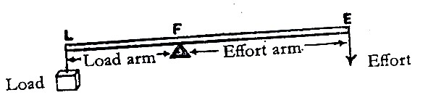

**Examples of levers**

|  |  |
| --- | --- |
| * Pliers * Pair of scissors * Wheel barrow | * See saw * Pair of tongs etc |

**Classes of levers**

Levers are classified according to the position of the fulcrum (pivot), effort and load in a machine

There are three classes of levers namely;

1. First class levers
2. Second class levers.
3. Third class levers.

**First class levers**

A first class lever is a class of levers where the pivot is in between the load and the effort (LPE). The pivot may exactly be in the middle or closer to either the effort or load.

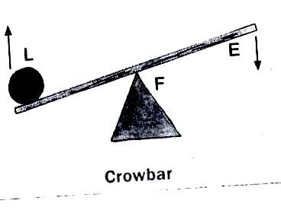

**Illustration**

The distance of the effort or load from the fulcrum is important when using a first class lever. This is because first class levers reduce the effort required to do work when the effort arm is longer than the load arm.

The longer the effort arm, the smaller the effort applied.

Therefore, to reduce the effort used in a first class lever, you make the effort arm longer than the load arm.

Most of the first class levers are used by applying the effort downwards. This makes the load move upwards. So they change direction of force.

**Advantages of using first class levers**

1. They reduce the effort required to do work
2. First class levers change direction of force

**Examples of first class levers**

|  |  |  |  |
| --- | --- | --- | --- |
| 1 | see saw | 2 | crow bar |
|  | See saw |  |  |
| 2 | pincers | 3 | pliers |
|  |  |  |  |
| 4 | claw hammer | 5 | water pump |
|  |  |  |  |
| 4 | pair of scissors | 8 | lid opener |
|  |  |  |  |
| 9 | sets of scales | | |
|  |  | | |

**Exercise**

1. Define the term levers.
2. What name is given to the turning point of a machine?
3. Mention one advantage of the first class lever.
4. State one way in which the effort is reduced in first class lever.
5. How do machines in the first class lever reduce effort?
6. Mention any two examples of machines in the first class lever.
7. Why is a see saw regarded as a machine in the first lass lever?

**LESSON 38**

**Sub topic: Levers**

**Content: Second and third class levers**

A second class of lever is a class of levers where the Load is in between the pivot and effort **(PLE)**

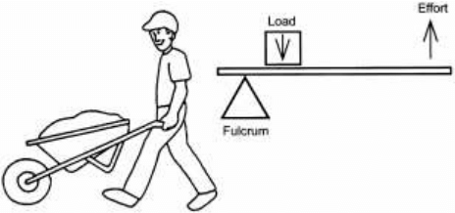**Illustration**

In this class of levers, the load is closer to the fulcrum than the effort is. The effort applied is smaller compared to the load.

First and second class levers are referred to as force multipliers because they reduce the effort needed to do work.

Second class levers do not change direction of force.

**Examples of second class levers**

|  |  |  |  |
| --- | --- | --- | --- |
| 1 | Wheel barrow | 3 | Human Foot |
|  |  |  |  |
| 2 | Nut cracker | 4 | Bottle opener |
|  |  |  |  |

**Third class levers**

A third class lever is a class of levers where the effort is in between the load and the pivot (PEL).

**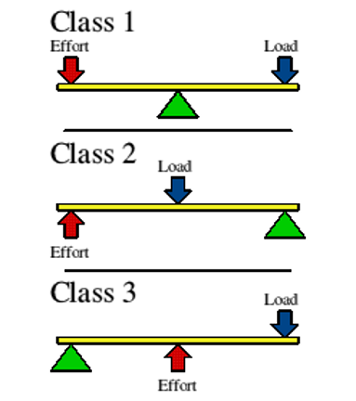Illustration**

**Load**

**Pivot**

In this class of levers, the effort is closer to the pivot than the load.

The effort used is greater than the load.

Third class levers are referred to as distance multipliers because the load moves through a longer distance than effort.

The advantage of using this class is that the effort moves through a shorter distance than the load.

**Examples of third class levers**

|  |  |  |  |
| --- | --- | --- | --- |
| 1 | Sugar tongs | 2 | Fishing rod. |
| 3 | Human arm | 4 | Spade |
| 5 | Tweezers | 6 | Table knife |

## **Exercise**

1. Write down any two examples of each of the following.

a) 1stclass lever

b) second class lever

1. State any one advantage of using first class levers 3. Draw any two machines

classified as 1st class levers

1. How are machines important in life?
2. State any two ways by which machines improve their efficiency?
3. How are the first class levers different from second class levers?
4. Give two examples of the third class lever.
5. Give one advantage of the first class lever over other classes of levers.

**LESSON 39**

**Sub topic: Levers**

**Content: Moments (**pratical use a see saw to demonstrate)

A moment is a turning effect of a force at a point.

For the lever to balance or to be in equilibrium, the left side moments must be equal to the right side moments.

**The principle of moments (The law of levers)**

It states that clock wise moments are always equal to anti-clock wise moments.

Therefore, the load force multiplied by the load arm is equal to the effort force multiplied by the effort arm.

This helps to balance the lever when working.

**Calculations about moments**

**Examples**

1. A man weighs 60kg. He sits 1.5 metres from the fulcrum of the see saw. How far from the fulcrum will the boy whose weight is 30 kg sit in order to balance with the man?

**Solution**

Let the man be the effort and the boy be the load.

Let the load be y metres.

y 1.5m

BOY

30

kg

MAN

60

kg

Load x Load arm = Effort x effort arm.

30kg x y=60kgx 1.5m

 = 

y = 3 metres

1. A boy weighing 60kg sits 2 metres away from the fulcrum of the see saw. A girl sits on the other side at a distance of 3 metres from the fulcrum in order to balance the see saw. Find the weight of the girl.

## **Solution**

2m 3m

60

Kg

X kg

Let the boy be the effort and the girl the load.

Let the girl’s weight be y

Load x Load arm=Effort x Effort arm

y x 3m =60Kgf x 2 metres.

3y = 12040

3 3

**y = 40kgf**

3. A weight of 120Kgf at a distance 3cm from the fulcrum is balanced by a weight of 30Kgf on the other side. Find the distance from the 30kg weight to the fulcrum.

## **Solution**

Take 120kgf as the load and 30kg as the effort

Let k be the distance of the effort from the fulcrum.

Load x Load arm = Effort x Effort arm

120kg x 3cm = 30kg x k

120 x 3 = 30x k

 = 

**k = 12m**

**Exercise**

1. Using a see-saw shown below, find the length of the wooden plank AB.

A 2m B

5

kgf

3

kgf

1. A boy weighing 60kg sits 3 metres away from the fulcrum of the see saw. A girl sits on the other side at a distance of 3 metres from the fulcrum in order to balance the see saw. Find the weight of the girl.

3. A man weighs 60kg. He sits 1.5 metres from the fulcrum of the see saw. How far from the fulcrum will the boy whose weight is 30 kg sit in order to balance with the man?

**LESSON 40**

**Sub topic: Inclined planes**

**Content: An inclined plane** (Real objects; staris, ladders)

An inclined plane is a slanting surface. Inclined planes are also called slopes.

An inclined plane connects a lower level to a higher level. It is used when we want to lift a load through a certain height we cannot reach with ease.

When an inclined plane is used, less effort is used to climb, lift or move objects from one level to another. However the distance increases when using inclined planes.

To make work easier when using an inclined plane, you increase on the length of the slope

**Illustration of an inclined plane**

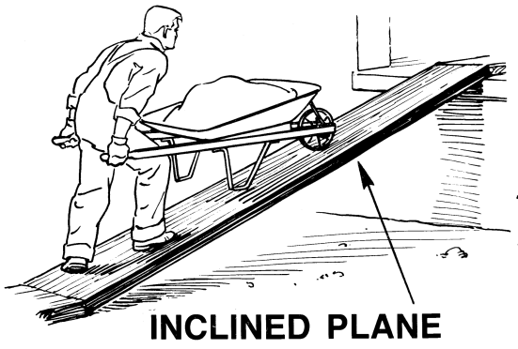

Slope

**Examples of inclined planes**

|  |  |  |  |
| --- | --- | --- | --- |
| 1 | winding road | 3 | ladders |
|  |  |  |  |
| 2 | stairs/ steps. | 4 | winch |
|  |  |  | C:\Users\Guest\AppData\Local\Microsoft\Windows\Temporary Internet Files\Content.Word\deco_well-winch.png |

**Importance of an inclined plane**

* 1. Inclined planes are used for loading and offloading vehicles.
  2. Inclined planes are used to climb tall buildings.
  3. Inclined planes make movement in hilly areas easy.
  4. Inclined planes are used for climbing tall trees.

**Exercise**

1. What is an inclined plane?
2. Write two examples of inclined planes
3. Write two ways inclined planes are useful in our daily life

Two men were lifting a load through the same height as shown below. Study the illustrations use them to answer questions that follow

**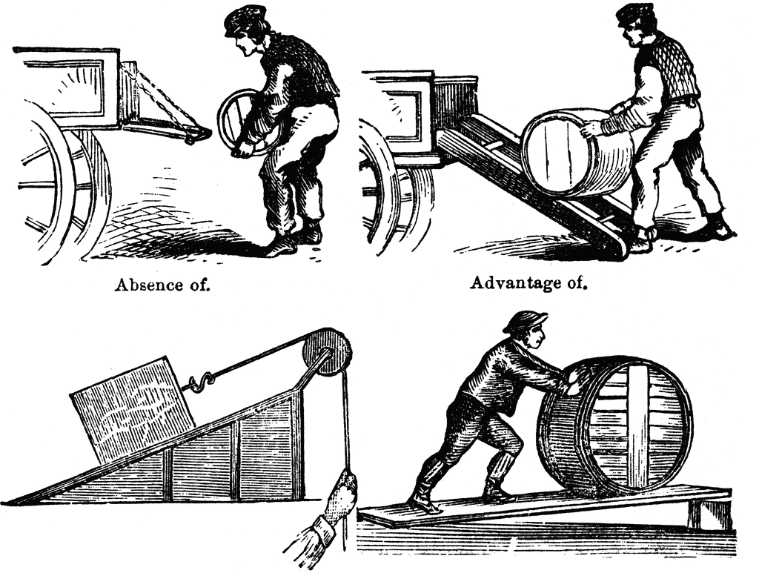**

**A B**

1. Who of the two men used;
2. Less effort
3. More effort
4. Give a reason for your answers in no (4) above

**LESSON 41**

**Content: Mechanical Advantage of machines**

As machines simplify work, they do it at different rates. The rate at which a machine simplifies work determines its mechanical advantage and efficiency.

Mechanical advantage is the number of times a machine simplifies work.

Mechanical advantage has no units.

A machine is said to have a mechanical advantage if the effort used to carry the load is less than the load.

**Note**

The mechanical advantage of a machine can be lowered by friction.

Mechanical advantage has no units.

To get the mechanical advantage of a machine, we divide the load by the effort.

i.e. **M.A = **

**Mechanical advantage of an inclined plane**

A

4m

5m

B

C

On an inclined plane, there are two distances i.e. the load distance and the effort distance.

The load distance is the distance through which you want to lift the load. For instance, on the above diagram, the load has to move from B to A. Therefore BA is considered as the **load distance**.

But because it is very difficult for anyone to lift the load from B to A directly, we place the load along the slope at point C and slowly push it until it reaches point A where we want it to be. This makes the work easier.

So, CA is the distance through which we move/push the load on an inclined plane, therefore it is called effort **distance.**

In summary, BA is the **load distance** while CA is the **effort distance**.

If you want to use less effort, you increase the length of the slope.

The longer the slope, the less effort used on an inclined plane

The mechanical advantage of an inclined plane can be got in two ways;

1. M.A = 

We use this formula when the load and effort have been given.

1. M.A = Effort distance

Load distance

We use this formula when the effort distance and load distance have been given.

**Example**

1. John used a slope to raise a load of 60kg from the ground to the higher level using an effort of 20kg as shown below.

C

20 kg

60kg

A B

In this case, 60kg is the load and 20kg is the effort

so M.A = 

= 

= 3

**Therefore the mechanical advantage is 3**

2. Lumolo raised a load through a distance of 6m. If the effort he used moved through a distance of 12m. Find the mechanical advantage of the machine he used.

In this case, 6m is the load distance and 12m is the effort distance.

M.A = Effort Distance

Load Distance

M.A = 

= 2

**Exercise**

1. Olupo raised a load of 600kg using an effort of 300kg on an inclined plane. Work the

mechanical advantage of the machine he used.

1. A builder raised a load through a distance of 12m.if the effort moved through a distance of 36m. Calculate the mechanical advantage of the machine he was using.
2. An effort of 40kg was used to raise a load of 80 kg using an inclined plane.
3. Represent the above information on a diagram.
4. Calculate the mechanical advantage of the above machine.

4. Juma raised a load 100kg through a distance of 25m. if the effort moved through a distance

of 50m.

1. Represent the above information on a diagram.
2. Find the mechanical advantage of using the machine above.

**LESSON 45**

**Content: Work**

Work is a product of force and the distance moved in the direction of force.

Work is said to be done when a force moves another force through a certain distance. For example, when you carry a jerry can of water from one place to another, you have done work.

Carrying a jerry can, you are using energy (force). A jerry can you are carrying is another force. So when you carry it through a distance you have done work.

Work is measured in units called **joules.** To find work done, we multiply the force by the distance. i.e.

**Work = force x distance**

## **Note**

A joule is the work done when force moves through a distance of 1 metre.

The standard unit for measuring force is **Newton.**

**1 kg = 10N**

The standard unit of distance is the **metre.**

**Examples**

1. A cook carried a load of 50N through a distance of 5m. Calculate the work done by the cook.

**Solution**

Work done = force X distance.

=5ONX5m

=50x5

## **=250 Joules**

2. A load of 20kg was moved through a distance of 3m. Find the work done.

Work done =force x distance

For this case, force has been given in kg. So we shall first have to change it into Newtons. This is because force is measured in Newtons.

1kg =10N

20kg = (20x10) N

=200N

**Therefore, force= 200N**.

(We shall now go back to our formula)

Work done = force x distance

= 200N X3m

=200x3

=600J.

**Exercise**

1. An object of weight 10N was moved through a distance of 5m. Find the work done.
2. A man used a wheel barrow to push a load of 20kg through a distance of 10m. Calculate the work done.
3. An inclined plane was used to lift a load of 50kg through a distance of 10 m using an effort of 25kg.
   1. Represent the above information on a diagram.
   2. Calculate the mechanical advantage of using the above machine.
4. An effort of 40N is applied on a lever to overcome a load of 200N. Calculate the

mechanical advantage.

1. The diagram below shows a simple machine. Use it to answer questions that follow.

**K**

40kg

3m 6m

80kg

**L** 6m **A**

1. Identify the following
   1. Effort distance
   2. Load distance
2. Calculate the mechanical advantage of the machine above.
3. How can the machine above be used with less effort?

**LESSON 46**

**Content: Wedges and screws** (Real objects; wooden wedge, axe, knife, nail, needle, razorblade)

**Wedges**

A wedge is any sharp object with a cutting edge.

It is made up of double inclined plane/slopes placed together to form a sharp edge. This is why wedges are also known as double inclined planes.

**Illustration of a wedge**

Slopes

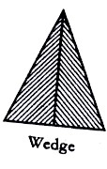

# **Examples of wedges**

|  |  |
| --- | --- |
| Knife edge. | Axe blade |
| Hoe | Razor blade |
| Nail | [Needl](http://adaptstudio.ca/blog/uploaded_images/needle-769308.png)e |

**Uses of wedges**

1. Wedges are used for cutting objects.
2. Wedges can be used for sewing.
3. Wedges are used for splitting wood.
4. Wedges are used for digging.

**Screws** (real objects; screw, nails, bolts and nuts)

A screw is an inclined plane wound round the rod. A rod is a thin straight bar made of either wood or metal.

A screw can also be regarded as a winding slope. The protruding spiral edges along the screw are called thread. The distance between two threads is called pitch.

The end of a screw is a sharp point. The head has a groove into which a screw driver is fixed when driving the screw into the wood.

**Diagram showing parts of a screw**

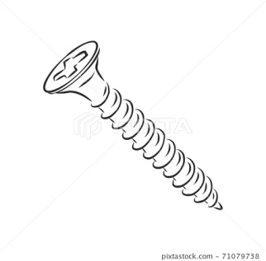 pitch

head

threads

**Examples of screws**

|  |  |  |
| --- | --- | --- |
| Screw | Structure | Function |
| spiral stair case |  | It makes movement upstairs easier |
| screw jerk |  | It is used for lifting vehicles when changing tyres |
| screw nail |  | It is used for drilling holes in wood |
| bolts and nuts | C:\Users\Guest\AppData\Local\Microsoft\Windows\Temporary Internet Files\Content.Word\Nuts-and-bolts-720x380.png | They are used for fastening pieces of wood or metal together. |

## **Exercise**

1. Name any one wedge used in the preparation of land.
2. Give a reason why a razor blade is regarded as a wedge.
3. Give any two applications of screws in our daily life.
4. Identify any two examples of screws

**LESSON 47**

**Content: Wheel and axle** (Real object; door knob, brace, car steering wheel)

A wheel and axle machine is a machine that has a wheel rotating on a rod. The rod on which a wheel rotates is called an axle. Wheels make it easy to move things.

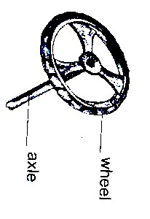**Examples of wheel and axle machines**

|  |  |  |  |
| --- | --- | --- | --- |
| Door knob | Pedal wheels | | Car steering wheels |
|  |  | |  |
| Egg beaters | Screw drivers | | brace |
|  |  | |  |
| Windlass | | Bicycle handles | |
|  | |  | |

# **Uses of wheel and axle**

There are several ways people use wheel and axle machines. These include

1. They are used for drawing water from underground tanks.
2. They are used for drilling holes in wooden materials.
3. They are used for tightening screws to fix things together.
4. They are used to loosen screws.
5. They are used for whisking eggs for frying.

**Exercise**

* + - 1. Write two examples of machines under wheel and axle.
      2. How are screw drivers useful to people.
      3. Use the diagram below to answer questions that follow.

**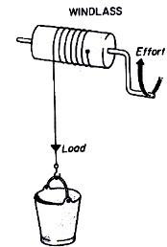**

1. Name the machine shown above.
2. To which class of simple machines does it belong?
3. Use an arrow to show the direction of the load.
4. Identify any one force which may fail the proper working of the above machine.

**LESSON 48**

**Content: Gearwheels/cog wheels or toothed wheels and belt drives**(audio-visual)

A gearwheel is a special form of the wheel with teeth around its edge.

These teeth interlock with the teeth of another gear wheel. When one turns it causes the other one to turn but rotate in opposite directions

**Illustration**

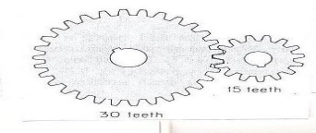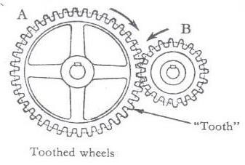

**Examples of machines thatuse gear wheels**

1. Watches
2. Gear boxes
3. Motor cycles
4. Bicycles
5. Electric toys
6. Bulldozers etc.

**Importance of gear wheels**

1. They help to multiply force
2. They change direction of movement
3. They multiply the speed of rotation
4. They can be used to slow the speed of rotation

**Belt drives**

Belt drives transmit movement from one wheel to another. Both wheels move in the same direction.

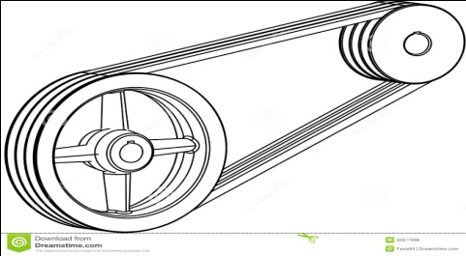**Illustration**

**Examples of machines that have belt drives**

1. Bicycles
2. Sewing machines
3. Grain mills
4. Cooling fan of car radiators
5. Conveyor belts

**Uses of belt drives**

They are used in factories to transmit and transport manufactured products.

**Exercise**

1. Give any two examples of each of the following:
   1. Wheels and axles
   2. screws
2. How are screws important to people?
3. Give any two groups of people who use screws in their work
4. Cite any two examples of wedges at home.
5. How are inclined planes important to human beings?

**LESSON 49**

**Content: pulleys** (Real objects / Audio visual)

A pulley is a wheel with grooved rim that rotates freely about an axle through a centre. A rope or chain passes over the pulley and is prevented from slipping by the grooved wheel.

The frame which holds the pulley is called block.

**Importance of pulleys**

1. They help in lifting objects from the lower level to higher level.
2. They help in lifting heavy loads during building.
3. They help in off loading heavy vehicles.
4. They help in towing vehicles.
5. They are used to raise flags on the poles.
6. They are used to move window curtains.

**Types of pulleys**

**There are different types of pulleys. These are;**

1. Single fixed pulley
2. Single movable pulley.
3. Block and Tackle system.

**Single fixed pulley**

This is a type of pulley which is fixed on a support and does not move. On one side of the string, a load is tied and on the other side effort is applied by pulling the string.

When the string is pulled downwards, the load moves upwards. This means it changes direction of force needed to lift the load making lifting of objects easier.

When using a single fixed pulley, the effort applied is equal to the load. This gives it a mechanical advantage (M.A) of 1

**Illustration of a single fixed pulley**

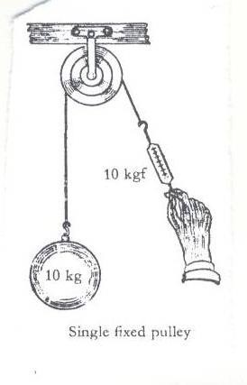

**Calculations involving single fixed pulleys**

**Example**

If a load of 30kgf is to be raised using a single fixed pulley, find the effort needed

M.A = load/Effort

1 = 30/E

E x 1 = 30

E = 30kgf.

**Exercise**

1. What is a pulley?
2. State any one application of pulleys at school.
3. Write two types of pulleys.
4. A man used a single fixed pulley to raise a load of 60 kg. How much effort did he use?

**LESSON 50**

**Single movable pulley**

In a single movable pulley, the string that goes round the pulley is fixed on one side and effort is applied on the other side. The load is tied to the pulley and it moves along with the moving pulley.

A single movable pulley is supported by two sections of the string.

**Illustration**

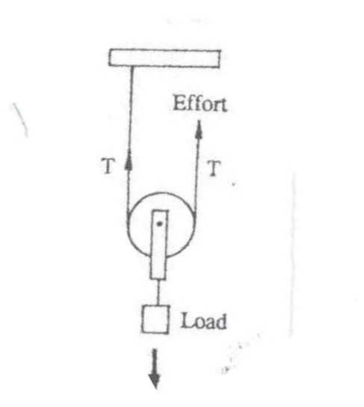

A single movable pulley does not change direction of force. The load and effort move in the same direction.

Because there are two sections of the string, a single movable pulley has a mechanical advantage of 2 and therefore reduces the effort required by half the weight of the load.

This makes lifting of objects with this pulley easier.

**Calculations involving single movable pulleys**

**Example**

If a load of 30kgf is to be raised using a single movable pulley, Find the effort needed. M.A = 2 L = 30kgf E =??

M.A = L/E

2 = 30/E

2 x E = 30

2E = 30

2 2

E =15kgf.

**Differences between fixed and movable pulley**

|  |  |
| --- | --- |
| **Fixed pulley** | **Movable pulley** |
| Work is done faster | Work is slower |
| It changes direction of force | It does not change direction of force |
| The effort applied is equal to the load. | Effort applied is half the load force. |
| It has a mechanical advantage of 1 | It has a mechanical advantage of 2 |

**Exercise**

1. State one difference between a single fixed and a single movable pulley.
2. What force will be needed to raise a load of 50kg using a single movable pulley?
3. A man used a single movable pulley to raise a load of 84kg. What effort did he use?
4. Kapere used an effort of 20kg to raise a load of 40kg using a pulley.
5. What type of pulley did he use?
6. Give a reason for your answer in (a) above.

**LESSON 51**

**Content: Block and tackle system, comparision of body parts to simple machines**

**Block and tackle pulley system**

This is a system where several movable and fixed pulleys are joined by strong ropes. It does work more easily because it is a combination of both fixed and movable pulleys. It changes direction of force.

Block and tackle pulleys are commonly used to lift heavy loads from ships, wagons and in industries where heavy machinery needs to be lifted.

**Illustrations**

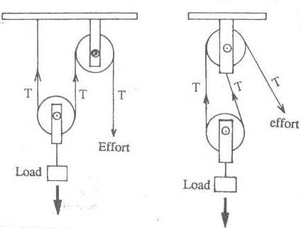

The mechanical advantage of a block and tackle pulley is determined by the number of wheels in the block.

**Note:**

The efficiency of pulleys is affected by two major forces. These are;

**Friction and the force of gravity** (test book, real objects)

**Comparison of body parts to simple machines**

Some body parts act as simple machines. Some of the parts which act as simple machines on our bodies include;

1. The neck region
2. The human foot
3. The human arm

**The neck region**

The point between the skull and the bones of the neck region form a first class lever. The spinal cord is the fulcrum at which muscles lift the head.

**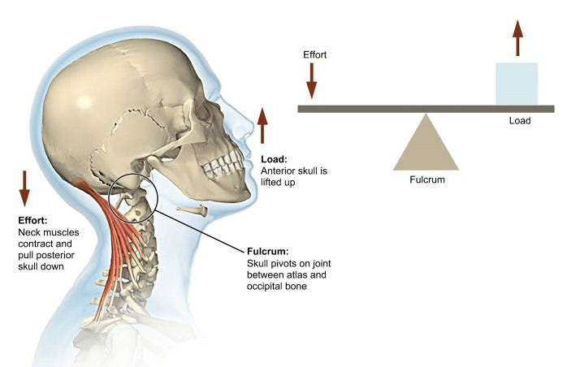Illustration**

**The human foot**

The Achilles tendon pushes or pulls across the heel of the foot when walking, running or jumping. This forms a second class lever

**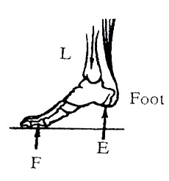Illustration**

**The human arm**

When lifting an object, the elbow joint acts as the pivot across which the biceps muscle performs the work. This forms a third class lever.

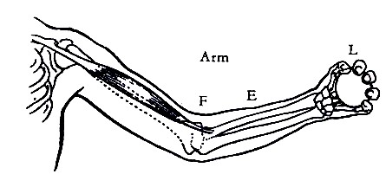**Illustration**

**Exercise**

1. Use the illustration below to answer questions that follow.



Name the machine above.

1. If the above machine of 36kg. calculate the effort used.
2. How are pulleys useful to builders?
3. Write two forces which may lower the efficiency of a pulley.

**END**